

CAPSTONE PROJECT REPORT
Report 3 – Software Requirement Specification

– Hanoi, Sep 2026 –
Table of Contents
Change Log 4
Definition and Acronyms 5
I. Overall Requirements 7
1. Context Diagram 7
2. Main Business Flow 7
2.1 Platform and Healthcare Facility Partnership Onboarding 7
2.2 Family Registration and 4-Party Service Contracting 9
2.3 Examination Scheduling and Workload Balancing 9
2.4 Clinical Encounter and EMR Management 10
2.5 Financial Administration and Revenue Settlement (BF-05) 11
2.6 Contract Lifecycle, Complaints and Variations 12
3. Conceptual Data Model 14
3.1 Entity Relationship Diagram 14
3.2 Entity Description 14
3.3 Data Business Rules 23
3.4 System Configuration Parameters 25
4. User Requirements 26
4.1 Actors 26
4.2 Use Cases (UC) 28
4.3 Use Case Diagrams 33
4.4 Permission Matrix 38
5. System Functionalities 45
5.1 Screen Inventory 45
5.2 External API Inventory 51
5.3 Background Job Inventory 52
II. Use Case Specifications 54
1. Feature: Healthcare Service Package Management 54
1.1 Create & Configure Care Service Package 54
2. Feature: Contract & Legal Management 55
2.1 Establish & Manage B2B Manpower Supply Contract 55
2.2 Execute 4-Party Healthcare Service Retainer Contract 56
2.3 Contract Addendum & Subscription Renewal 57
3. Feature: Medical Personnel & Onboarding 57
3.1 Two-Tier Doctor Credential & CCHN License Verification 57
3.2 Assign Primary Care Physician with Panel Capacity Control 58
4. Feature: Family Health Profile Management 59
4.1 Register & Manage Household Members 59
5. Feature: Scheduling & Workload Balancing 60
5.1 Plan Routine Periodic Home & Telehealth Encounters 60
5.2 Facility Master Timetable & Conflict Balancing 61
6. Feature: Clinical Encounter, EMR & Prescriptions 62
6.1 Document SOAP Clinical Record & ISO 27799 Tamper-Proof Lock 62
6.2 Issue 1NF National Electronic Prescription & Clinical Referral 63
6.3 Encrypted WebRTC Telemedicine Consultation 64
7. Feature: Financial Billing, Payment & B2B Settlement 64
7.1 Dynamic VietQR Payment & Automated Webhook Reconciliation 64
7.2 Monthly B2B Revenue Settlement & Disbursement 65
8. Feature: Ratings, Dispute & Incident Arbitration 66
8.1 Platform Incident Arbitration & Dispute Resolution 66
III. Functional Requirements 67
1. Family Health Profile & Medical Timeline 67
1.1 Family Health Dashboard 67
1.2 View Longitudinal EHR Timeline & History 69
2. Doctor Onboarding, Verification & Matching Directory 71
2.1 Public Doctor Directory 71
2.2 Public Doctor Profile & Practice Schedule 73
2.3 Doctor Registration & Credentials Submission 75
2.4 Smart Doctor Matching Wizard 77
3. Chronic Care Continuous Monitoring & Vital Alerting 78
3.1 Record Vital Signs & Abnormal Threshold Alert 79
4. Hybrid Care (Video Calls & Home Visits) 80
4.1 Book Consultation Appointment (Home / Video) & Record SOAP Clinical Encounter 80
5. Healthcare Subscription & Service Contract Management 81
5.1 Subscribe to Care Package & Sign Electronic Contract 81
IV. Non-Functional Requirements 82
1. External Interfaces 82
2. Quality Attributes 84
2.1 Usability 84
2.2 Performance 84
2.3 Security 85
V. Requirement Appendix 85
1. Business Rules 85
2. System Messages 89
3. Other Requirements 91

Change Log
Date | A*  M, D | In charge | Change Description
26/09/2026 | A | Pham Xuan Hung | V0.1 - Initial draft
28/09/2026 | M | Chu Ngoc Dung | Added Section 2.3 (Home Visit & Telehealth Appointment and Clinical Encounter Process) including its trigger and end condition, inserted the corresponding main flow diagram, and added the Use Case diagrams for Guest and Family Representative.
05/10/2026 | M | Nguyen Minh Hieu | Revised the system boundaries and business rules documentation. Clarified the justification text to explicitly state that interfacing with external hospital systems falls outside the scope of FamiDoc.
05/10/2026 | M | Nguyen MinhHieu | Updated Context Diagram (Section I.1), Use Case diagrams (Section I.4.3) and Main Business Flow diagrams (Section I.2) to ensure consistency with the revised business rules and overall system requirements.
06/10/2026 | M | Chu Ngoc Dung | Added Section 2.1 (Search and View Doctor Directory & Profile) and Section 2.2 (Admin Verify Doctor License & Credentials), updated Use Case diagrams for Guest and Family Representative, and added corresponding screens and descriptions.
06/10/2026 | M | Nguyen Hoai Nam | Update the screen flow and screen list. Re-list the use cases to ensure alignment, create wireframes for the admin interface, and rewrite the descriptions for those wireframes.
08/10/2026 | M | Chu Ngoc Dung | Added Section 4.3.1 Use Case diagram for FamiDoc
08/10/2026 | M | Nguyen Minh Hieu | Fixed minor formatting inconsistencies and resolved conflicting cross-references and queries throughout the document to improve overall readability and consistency.
08/10/2026 | M | Chu Ngoc Dung | Updated main flow diagrams and descriptions for Section 2.4 (Hybrid Care Delivery & Clinical Encounter Execution), Section 2.5 (Continuous Health Monitoring, Alerting & Preventive Intervention), and Section 2.6 (Contract SLA Evaluation, Dispute Resolution & Escrow Settlement).
08/10/2026 | M | Nguyen Hoai Nam | Update the main business flow section based on the new use cases, comprising three workflows: Family Onboarding & Initial Longitudinal EHR (BF-01); Doctor Onboarding, License Verification & Practice Setup (BF-02); and Doctor Discovery, Care Plan Contracting & VietQR Activation (BF-03). Revise the Admin use cases to align with the new business flows and use cases.
09/10/2026 | M | Pham Xuan Hung | Align context, business flows, use cases, permissions and inventories with the 24-use-case baseline.
09/10/2026 | M | Pham Xuan Hung | Rewrite BF-01–05 with related use cases and exception branches; remove BF-06, geolocation, refunds and deferred finance entities.
09/10/2026 | M | Pham Xuan Hung | Add missing conceptual entities and redraw actor-specific use-case diagrams without internal infrastructure actors.
09/10/2026 | M | Pham Xuan Hung | Synchronize names, states, rules, messages and interfaces; clarify prototype privacy, prescriptions and payment behavior.
09/10/2026 | M | Chu Ngoc Dung | Updated BF-04 end condition, updated BF-05 and added VITAL_THRESHOLDS parameter in Section 3.4, and revised Use Case diagrams for FamiDoc, Guest, and Family Representative.
15/10/2026 | M | Chu Ngoc Dung | Revised all use case diagrams and added the Healthcare Facility actor use case diagram
16/10/2026 | M | Chu Ngoc Dung | Added UC-39 (Request Medical Care & Book Visit) to the Use Case list in Section 4.2.
15/10/2026 | M | Nguyen Hoai Nam | Refined Administrator Use Cases (Admin UC alignment), and completely revised Main Business Flows BF-05 (Financial Settlement) and BF-06 (Contract Lifecycle & Dispute Resolution) with optimized swimlane activity diagrams.
19/10/2026 | M | Pham Xuan Hung | Update use case specifications audit after review
21/10/2026 | M | Nguyen Hoai Nam | Updated Main Business Flows BF-05 and BF-06 to clarify payment timeout, automated monthly settlement, contract renewal, upgrade, and early liquidation processes.
*A - Added M - Modified D - Deleted

Definition and Acronyms
Acronym | Definition
FamiDoc | Family Doctor Management & Healthcare Platform — A digital platform connecting households directly with dedicated private family doctors.
Family Rep | Family Representative — The designated primary account holder who manages family health profiles, dependents, and contracts.
Family Doctor | A licensed medical practitioner with an official practicing certificate (CCHN) providing continuous, comprehensive healthcare.
Retainer Contract | A prepaid periodic subscription agreement (monthly/quarterly/annual) establishing a continuous 1-on-1 concierge care relationship.
Clinical Encounter | A comprehensive medical examination session conducted either in-person at the patient's home or via encrypted video.
EHR | Electronic Health Record — Longitudinal digital health history encompassing vital signs, medical history, allergies, and lab reports.
SOAP Format | Standard clinical documentation format: Subjective (symptoms), Objective (vitals/findings), Assessment (diagnosis), Plan (care plan).
ICD-10 | International Classification of Diseases, 10th Revision — Standardized global diagnostic coding classification system.
E-Prescription (E-Rx) | Digitally validated prescription containing drug interaction checks, dosage instructions, and automated reminders.
Panel Cap | Patient capacity limit — The maximum number of active family contracts a doctor is permitted to manage concurrently.
WebRTC | Web Real-Time Communication — Open standard protocol enabling peer-to-peer (P2P) encrypted audio/video streaming.
STUN/TURN | Network traversal infrastructure enabling WebRTC media streaming across firewalls and NAT networks.
VietQR | National standard for automated dynamic banking QR code generation with IPN webhook payment confirmation.

I. Overall Requirements

1. Context Diagram

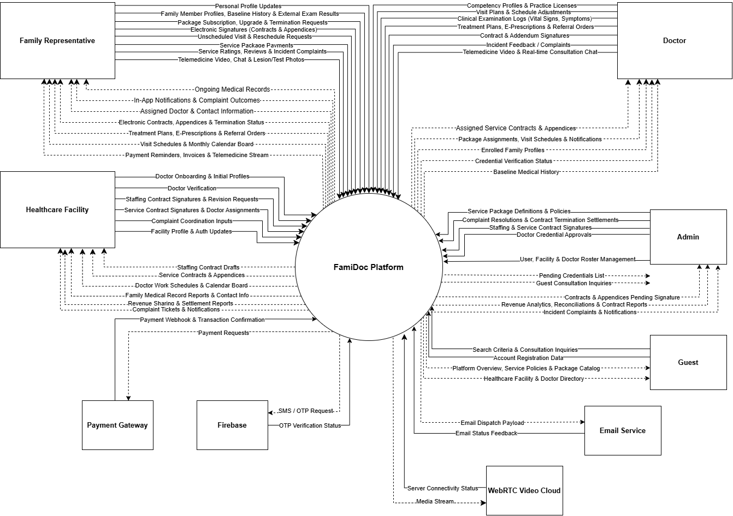

2. Main Business Flow

2.1 Platform and Healthcare Facility Partnership Onboarding
Trigger: The Administrator and the Healthcare Facility negotiate, establish and digitally sign the Human Resource Supply Cooperation Contract, defining the doctor qualification commitments and the revenue-sharing ratio.
End condition: The Facility registers its affiliated doctors and the system issues each account with an activation email; the doctors upload their practice licence, professional degrees and Family Medicine training certificate; the two-layer approval (Facility verification of personnel, then Admin post-audit of legal validity) activates the doctor as available to receive care packages on the platform.
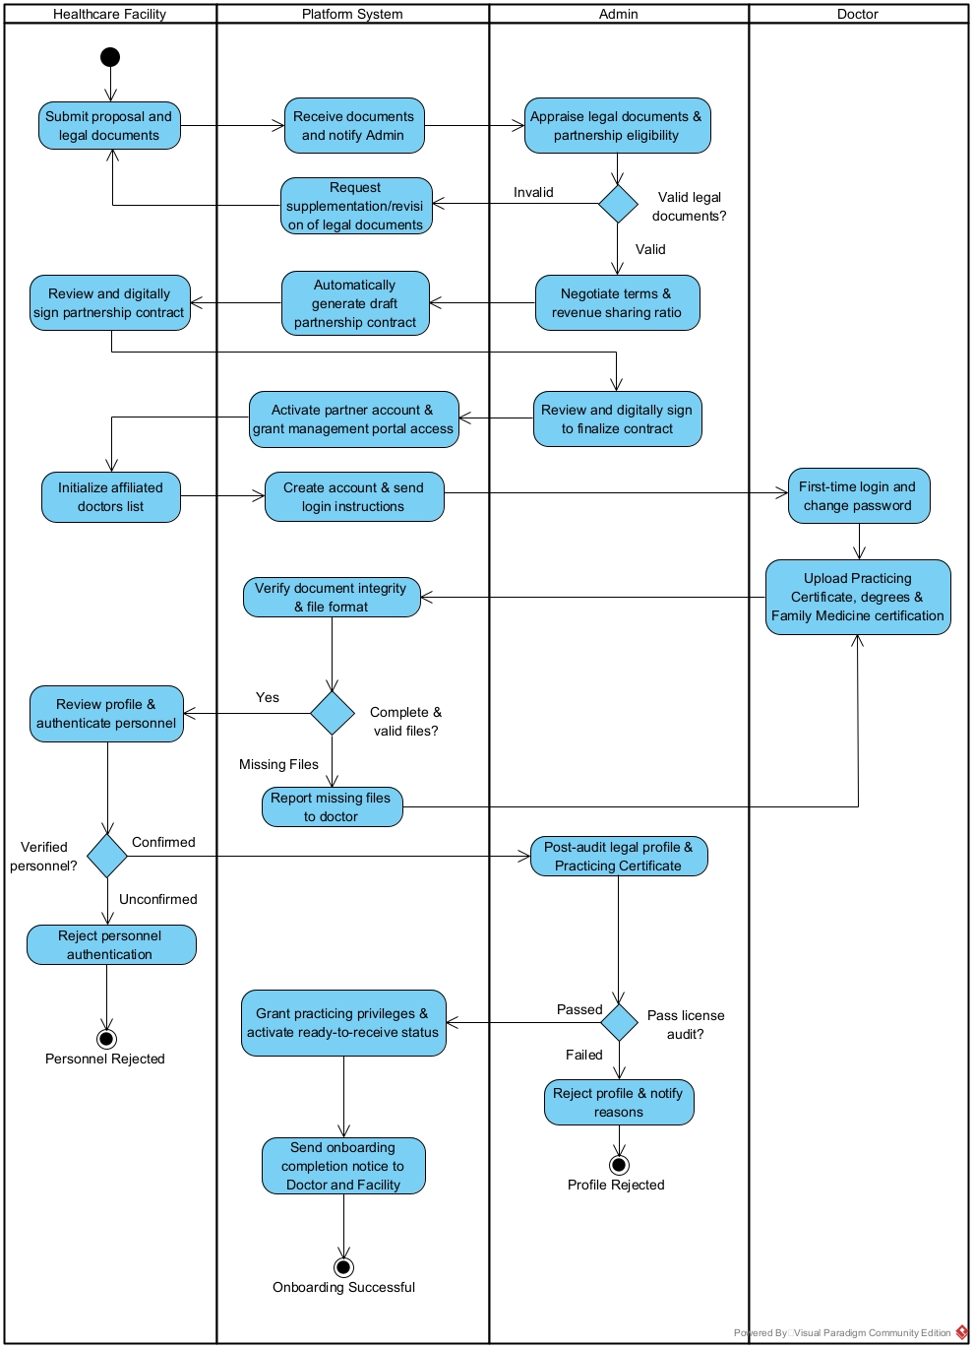

2.2 Family Registration and 4-Party Service Contracting
Trigger: A Family Representative creates an account, declares the household members' demographics and initial medical history, and selects a care package, from which the system generates a draft electronic 4-party service contract.
End condition: The contract is signed sequentially by the Family Representative and the Administrator, then by the Healthcare Facility (which also assigns the attending doctor), then by the assigned doctor; the family's payment is reconciled automatically through the payment webhook and the contract becomes officially effective.
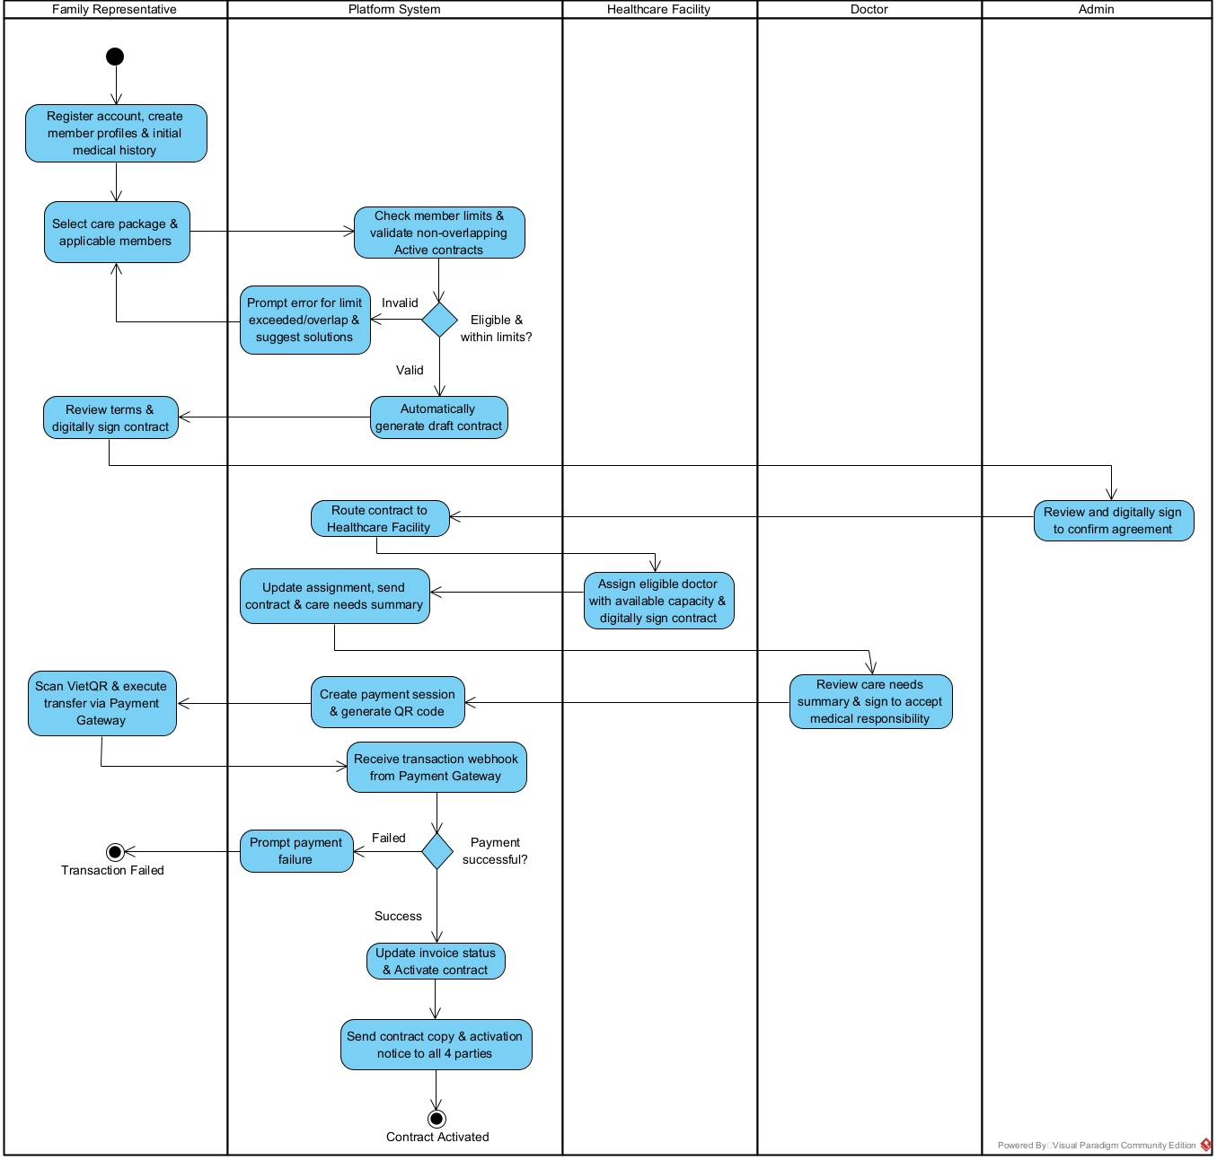

2.3 Examination Scheduling and Workload Balancing
Trigger: The attending doctor plans the examination roadmap based on the package entitlements and the family's medical history, selecting the form of care (Home Visit, Telemedicine, or examination at the Healthcare Facility).
End condition: The examination schedule is synchronised across the doctor's, the family's and the Facility's timetables; any reschedule request updates the shift board and sends automatic confirmation notifications and emails to both parties.
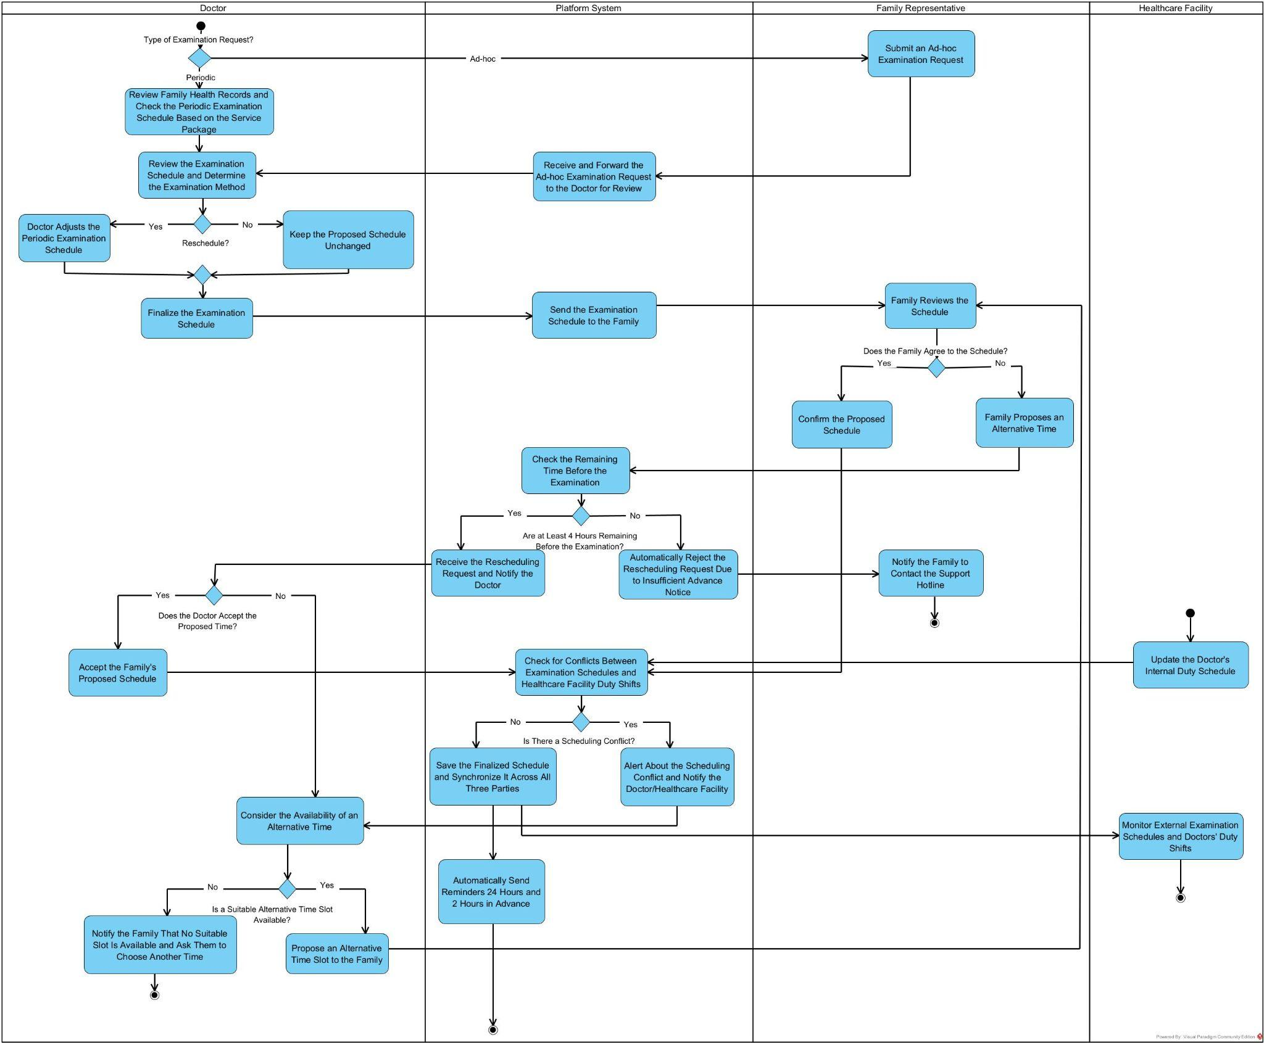

2.4 Clinical Encounter and EMR Management
Trigger: A confirmed consultation is performed, either as a direct clinical examination (Home Visit or at the Healthcare Facility) or as a Telemedicine session (video call, symptom chat, image sharing).
End condition: The doctor records the full encounter in the electronic medical record with real-time audit logging and issues the treatment decision (an e-prescription with monitoring guidance, or a referral to a higher-tier facility); the family's externally obtained results are uploaded to update the longitudinal record.
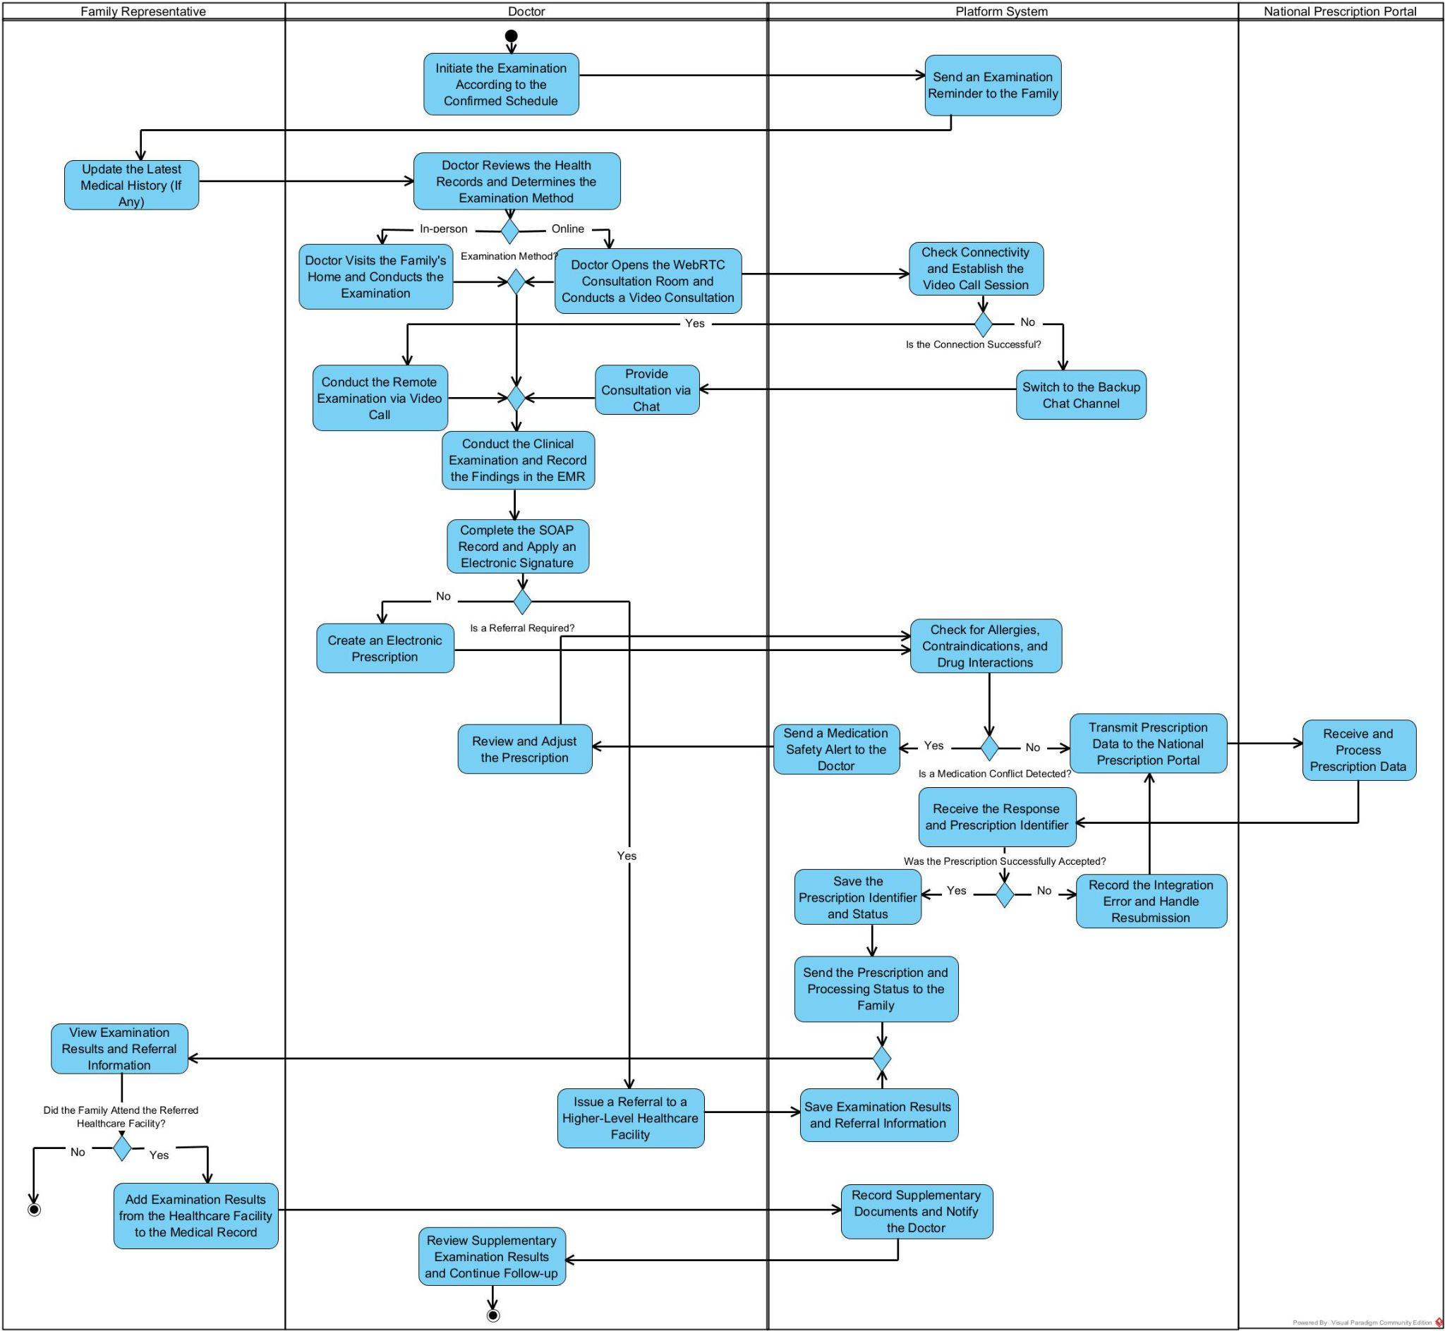

2.5 Financial Administration and Revenue Settlement (BF-05)
Trigger: After a signed service contract or addendum becomes eligible for payment, the Family Representative selects the payable item. FamiDoc generates a VietQR invoice valid for 15 minutes and waits for the Payment Gateway webhook.
End condition: After a valid webhook is verified, FamiDoc records the payment and activates the eligible contract or addendum. On the 5th of each month, the previous month’s eligible transactions are reconciled; FamiDoc retains 15% and transfers 85% to the Healthcare Facility, while taxes and invoices are recorded separately. A successful transfer is marked as Settled; a failed transfer remains Pending or Failed for retry or manual resolution. The Facility pays the doctor under its internal policy. 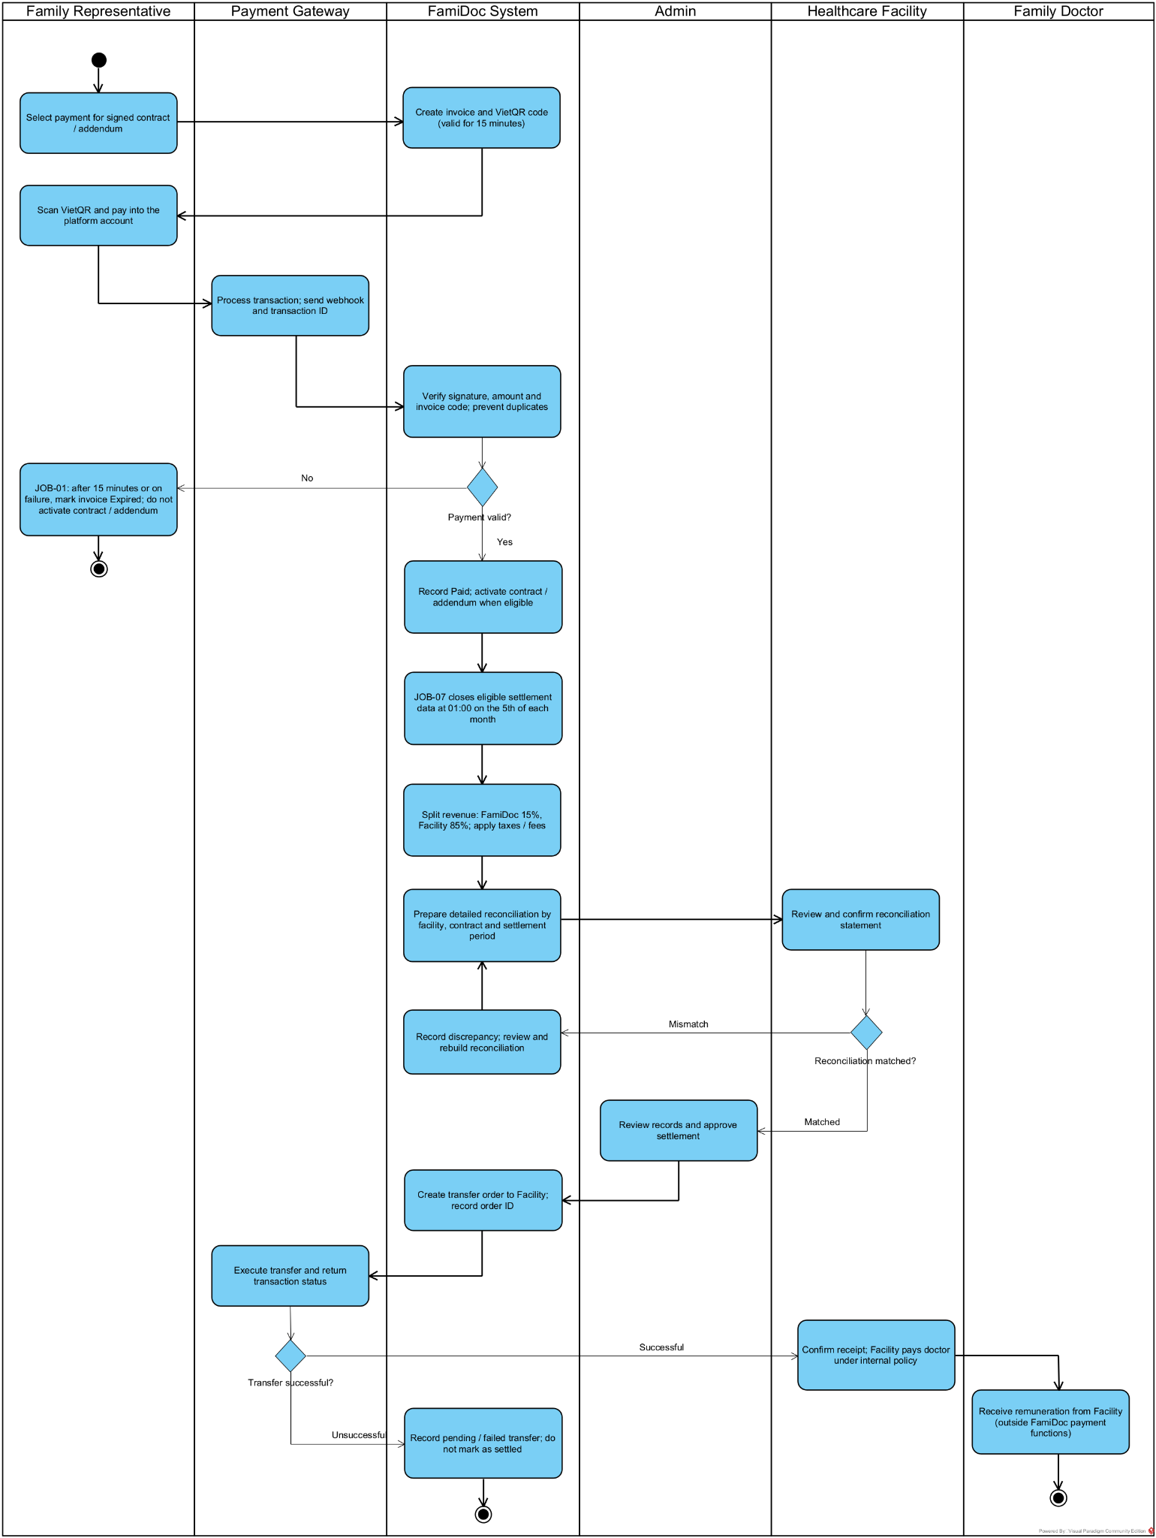

2.6 Contract Lifecycle, Complaints and Variations
Trigger: The flow starts when the Family Representative submits a rating for a completed Home Visit or Telehealth session, when the Family Representative or Doctor submits a complaint, or when the Family Representative requests an addendum, package renewal or upgrade, or early contract termination.
End condition: The flow ends when an eligible rating is saved once; a complaint is concluded after the Admin and Healthcare Facility verify the evidence and apply a non-financial measure under their respective authority, without refund or compensation; or the requested contract change is completed. An addendum takes effect only after the required signatures and payment. Renewal or upgrade creates a new non-overlapping contract after the old contract expires or is terminated early, with no unused-time carry-over. Termination updates the contract status, service rights and panel capacity, preserves medical records, and notifies all parties.
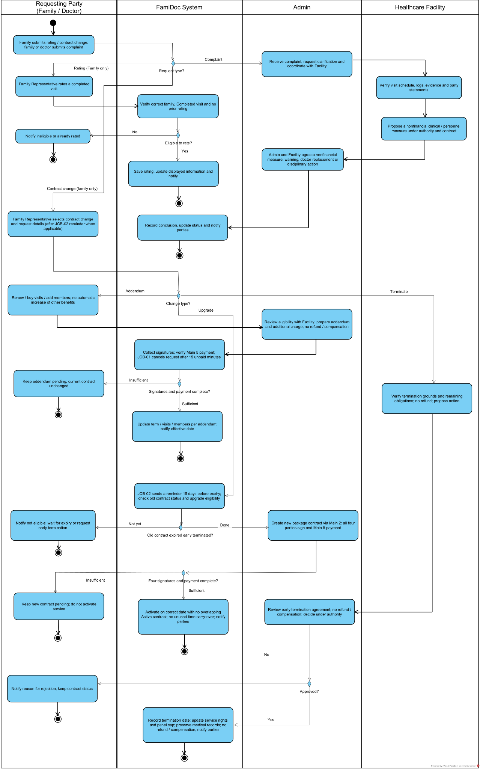

3. Conceptual Data Model

3.1 Entity Relationship Diagram
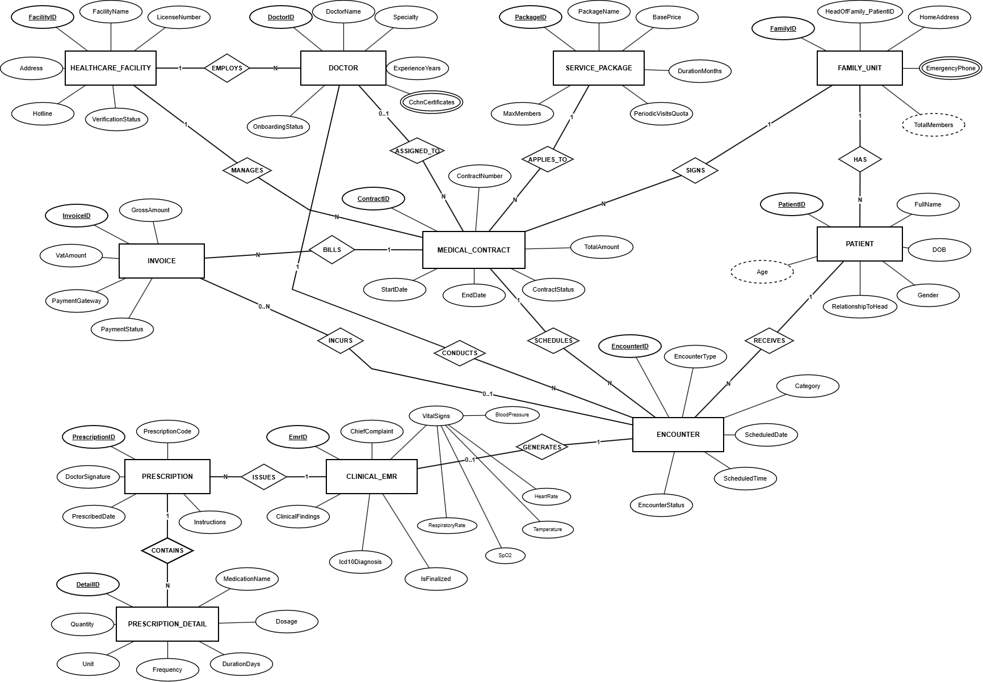

3.2 Entity Description
Entity: HEALTHCARE_FACILITY
Field | Value
Purpose | Verified medical institution (hospital, general clinic, family medical center) partnering with the platform to supply medical staff, manage contract delivery, and handle specialized escalations (UC-04, UC-09, UC-15).
Attributes in ERD Diagram | FacilityID (PK - Underlined), FacilityName, LicenseNumber, Address, Hotline, VerificationStatus.
Relationships & Pure Chen Cardinality | • EMPLOYS (1:N): Facility (1) employs Doctors (N) [Facility --- (1) EMPLOYS (N) --- Doctor].  • MANAGES (1:N): Facility (1) oversees Medical Contracts (N) [Facility --- (1) MANAGES (N) --- Contract].
Business identity | FacilityID is the surrogate primary key. LicenseNumber is unique nationwide (FAC-XXXXXX) issued by the Ministry of Health / Department of Health.
Status / lifecycle | Pending Verification → Active (verified practicing institution) → Suspended.
Entity: DOCTOR
Field | Value
Purpose | Certified primary care physician responsible for dedicated family healthcare management, conducting routine/ad-hoc home visits, clinical examinations, tele-consultation, electronic medical recording, and e-prescribing (UC-04, UC-09, UC-10, UC-11, UC-20, UC-23).
Attributes in ERD Diagram | DoctorID (PK - Underlined), DoctorName, Specialty, ExperienceYears, CchnCertificates (Multivalued - Double-oval), OnboardingStatus.
Relationships & Pure Chen Cardinality | • EMPLOYS (1:N): Doctor (N) belongs to Facility (1) [Doctor --- (N) EMPLOYS (1) --- Facility].  • ASSIGNED_TO (0..1 : N): Doctor is assigned as the primary attending physician for 0..N Contracts, with capability of reassignment if unavailable.  • CONDUCTS (1:N): Doctor (1) directly conducts 0..N Clinical Encounters [Doctor --- (1) CONDUCTS (N) --- Encounter] (supports locum/covering doctors).
Business identity | DoctorID is the surrogate primary key. Medical practice certificate (CCHN/GPHN) is unique nationwide and audited under national healthcare registry standards.
Status / lifecycle | Pending Verification → Verified (active practitioner on platform) → Suspended / Inactive.
Entity: SERVICE_PACKAGE
Field | Value
Purpose | Standardized periodic primary care subscription package offering preventive screening, routine home doctor check-ups, and 24/7 tele-triage quotas for household members (UC-06, UC-12, UC-13).
Attributes in ERD Diagram | PackageID (PK - Underlined), PackageName, BasePrice, DurationMonths, PeriodicVisitsQuota, MaxMembers.
Relationships & Pure Chen Cardinality | • APPLIES_TO (1:N): Service Package (1) defines terms applied to 0..N Medical Contracts [Package --- (1) APPLIES_TO (N) --- Contract].
Business identity | PackageID is the surrogate primary key. Package code / name is unique system-wide (e.g., PKG-STANDARD, PKG-PREMIUM).
Status / lifecycle | Draft → Active (open for enrollment) → Deprecated (closed to new subscriptions).
Entity: FAMILY_UNIT
Field | Value
Purpose | Household unit registered by a Family Representative that contracts for dedicated family doctor coverage and manages all dependent members (UC-01, UC-05, UC-13, UC-24).
Attributes in ERD Diagram | FamilyID (PK - Underlined), HeadOfFamily_PatientID (Foreign reference to head Patient), HomeAddress, EmergencyPhone (Multivalued - Double-oval), TotalMembers (Derived - Dashed-oval: computed as COUNT(Patient)).
Relationships & Pure Chen Cardinality | • HAS (1:N): Family Unit (1) contains One or Many Patients/Members [Family --- (1) HAS (N) --- Patient].  • SIGNS (1:N): Family Unit (1) enters into 0..N Medical Contracts [Family --- (1) SIGNS (N) --- Contract].
Business identity | FamilyID is the surrogate primary key. HeadOfFamily_PatientID references the registered head of household within PATIENT. Emergency phones ensure rapid crisis response.
Status / lifecycle | Active (registered household) → Suspended.
Entity: PATIENT
Field | Value
Purpose | Individual family members (children, elderly parents, spouse, or representative) covered under the family plan, receiving clinical visits, health tracking, and electronic prescriptions (UC-05, UC-16, UC-19, UC-24).
Attributes in ERD Diagram | PatientID (PK - Underlined), FullName, DOB, Gender, RelationshipToHead, Age (Derived - Dashed-oval: computed as CURRENT_DATE - DOB).
Relationships & Pure Chen Cardinality | • HAS (1:N): Patient (N) belongs to exactly One Family Unit [Patient --- (N) HAS (1) --- Family].  • RECEIVES (1:N): Patient (1) receives 0..N Clinical Encounters [Patient --- (1) RECEIVES (N) --- Encounter].
Business identity | PatientID is the surrogate primary key. Conforms to HL7 FHIR Patient resource specifications.
Status / lifecycle | Active (under active healthcare monitoring) → Inactive (archived/transferred).
Entity: MEDICAL_CONTRACT
Field | Value
Purpose | Central legal electronic retainer agreement between Family Unit and Healthcare Facility for a chosen Service Package, with an assigned attending Doctor, governing SLAs and visit quotas (UC-14, UC-15, UC-16).
Attributes in ERD Diagram | ContractID (PK - Underlined), ContractNumber, TotalAmount, StartDate, EndDate, ContractStatus.
Relationships & Pure Chen Cardinality | • Binary relationships: Facility (1) MANAGES (N) Contract; Package (1) APPLIES_TO (N) Contract; Family (1) SIGNS (N) Contract; Doctor (0..1) ASSIGNED_TO (N) Contract.  • BILLS (1:N): Contract (1) generates Invoices (N) [Contract --- (1) BILLS (N) --- Invoice].  • SCHEDULES (1:N): Contract (1) schedules Encounters (N) [Contract --- (1) SCHEDULES (N) --- Encounter].
Business identity | ContractID is the surrogate primary key. ContractNumber is unique system-wide (CTR-YYYY-XXXXXX). A household maintains at most one Active contract at any time.
Status / lifecycle | Pending Approval → Pending Payment → Active → Expired (term completed) or Terminated.
Entity: INVOICE
Field | Value
Purpose | Electronic billing record generated for contract subscription retainers OR out-of-package clinical encounter charges (ad-hoc extra visits, unlisted diagnostic tests, emergency surcharges), integrated with VietQR / banking gateway (UC-03, UC-15, UC-33, UC-34).
Attributes in ERD Diagram | InvoiceID (PK - Underlined), GrossAmount, VatAmount, PaymentGateway, PaymentStatus.
Relationships & Pure Chen Cardinality | • BILLS (1:N): Invoice (N) belongs to Contract (1) [Invoice --- (N) BILLS (1) --- Contract].  • INCURS (0..1 : 0..N): Invoice (0..N) can be incurred directly from an Encounter (0..1) for out-of-package medical fees [Encounter --- (0..1) INCURS (0..N) --- Invoice].
Business identity | InvoiceID is the surrogate primary key. Linked to banking transaction reference IDs via VietQR dynamic payment payload.
Status / lifecycle | Pending (awaiting payment) → Paid (reconciled via Webhook/IPN)
Entity: ENCOUNTER
Field | Value
Purpose | Scheduled clinical consultation event (in-home visit, clinic consultation, or tele-consultation) between an attending/covering doctor and a specific patient dependent (UC-07, UC-16, UC-17, UC-27, UC-28, UC-32).
Attributes in ERD Diagram | EncounterID (PK - Underlined), EncounterType (HomeVisit / Telehealth), Category, ScheduledDate, ScheduledTime, EncounterStatus.
Relationships & Pure Chen Cardinality | • SCHEDULES (1:N): Governed by Contract [Contract --- (1) SCHEDULES (N) --- Encounter].  • RECEIVES (1:N): Examines Patient [Patient --- (1) RECEIVES (N) --- Encounter].  • CONDUCTS (1:N): Performed directly by Doctor [Doctor --- (1) CONDUCTS (N) --- Encounter] (accurately tracks examining doctor even when covering for colleague).  • INCURS (0..1 : 0..N): Generates out-of-package Invoices (0..N) when ad-hoc fees occur.  • GENERATES (1 : 0..1): Generates at most 1 Clinical EMR [Encounter --- (1) GENERATES (0..1) --- Clinical EMR].
Business identity | EncounterID is the surrogate primary key. Conforms to HL7 FHIR Encounter resource standards.
Status / lifecycle | Requested / Pending → Confirmed → In Progress → Completed / Cancelled.
Entity: CLINICAL_EMR
Field | Value
Purpose | Official clinical encounter documentation containing anamnesis, physical examination findings, ICD-10 diagnosis codes, composite vital signs, and digital doctor signature (UC-18, UC-19, UC-30, UC-31).
Attributes in ERD Diagram | EmrID (PK - Underlined), ChiefComplaint, ClinicalFindings, Icd10Diagnosis, IsFinalized, VitalSigns (Composite Attribute branching into BloodPressure, HeartRate, Temperature, SpO2, RespiratoryRate).
Relationships & Pure Chen Cardinality | • GENERATES (1 : 0..1): Clinical EMR (0..1) is created from Encounter (1) [Encounter --- (1) GENERATES (0..1) --- Clinical EMR].  • ISSUES (1:N): Clinical EMR (1) issues 0..N Prescriptions [Clinical EMR --- (1) ISSUES (N) --- Prescription].
Business identity | EmrID is the surrogate primary key. Conforms to HL7 FHIR Composition/Condition standards and ISO 27799 clinical privacy regulations.
Status / lifecycle | Draft (editable during examination) → Finalized (digitally signed, locked, immutable).
Entity: PRESCRIPTION
Field | Value
Purpose | Legal electronic prescription header issued by the attending physician upon finalizing clinical findings, conforming to Circular 04/2022/TT-BYT and Circular 27/2021/TT-BYT standards (UC-20, UC-21, UC-31).
Attributes in ERD Diagram | PrescriptionID (PK - Underlined), PrescriptionCode, DoctorSignature, PrescribedDate, Instructions.
Relationships & Pure Chen Cardinality | • ISSUES (1:N): Prescription (N) issued by Clinical EMR (1) [Clinical EMR --- (1) ISSUES (N) --- Prescription].  • CONTAINS (1:N Identifying): Prescription (1) contains 1..N Prescription Details [Prescription --- (1) CONTAINS (N) --- Prescription_Detail].
Business identity | PrescriptionID is the primary key. PrescriptionCode is unique nationwide (RX-YYYY-XXXXXX) verifiable against the National Prescription Portal (donthuocquocgia.vn).
Status / lifecycle | Issued (digitally signed by doctor) → Filled (dispensed at pharmacy) → Archived.
Entity: PRESCRIPTION_DETAIL
Field | Value
Purpose | Itemized pharmaceutical medication line item specifying exact medication name, dosage form, total quantity, unit of measure, intake frequency, and treatment duration in strict accordance with First Normal Form (1NF) database standards.
Attributes in ERD Diagram | DetailID (PK - Underlined), MedicationName, Dosage, Quantity, Unit, Frequency, DurationDays.
Relationships & Pure Chen Cardinality | • CONTAINS (1:N Identifying): Prescription Detail (N) belongs to exactly One parent Prescription (1) [Prescription_Detail --- (N) CONTAINS (1) --- Prescription].
Business identity | DetailID is the primary key (composite key with PrescriptionID). Conforms to HL7 FHIR MedicationRequest resource line item specifications.
Status / lifecycle | Prescribed (active medication regimen) → Dispensed → Completed.

3.3 Data Business Rules
Rule | Description | Enforced On
BR-01: Unique Facility Accreditation Code | Every healthcare facility partnering with the platform must possess a unique, verifiable institutional license code (FAC-XXXXXX) issued by the Ministry of Health or municipal Department of Health. No duplicate medical institutions are permitted. | Facility Registration & Onboarding (HEALTHCARE_FACILITY.LicenseNumber)
BR-02: Mandatory Professional License & Certification | A family doctor must possess a valid, active medical practice certificate (CCHN/GPHN) and at least 3 months of family medicine continuing training (CchnCertificates). A doctor can only be active if approved by both their affiliated facility and system admin. | Doctor Onboarding & Verification (DOCTOR.CchnCertificates, DOCTOR.OnboardingStatus)
BR-03: Doctor Affiliation Exclusivity & Assignment | Each doctor is formally affiliated with exactly one primary Healthcare Facility (EMPLOY). While a contract is legally managed by the facility and client family, the doctor is assigned as the primary caregiver (ASSIGNED_TO) and may be transferred or reassigned without voiding the agreement. | Doctor Employment & Contract Assignment (HEALTHCARE_FACILITY - DOCTOR - MEDICAL_CONTRACT)
BR-04: Doctor Active Patient Panel Capacity Cap | To guarantee medical quality and safety, a family doctor cannot be assigned to new family contracts if their current active panel of managed households exceeds the system threshold MAX_PANEL_CAPACITY (default 30 families; max 50). | Doctor Assignment & Contract Activation (DOCTOR.DoctorID, CFG-01)
BR-05: Family Household Representative Binding | A family household (FAMILY_UNIT) is registered by a representative whose identity must be linked directly to a concrete dependent profile in PATIENT (HeadOfFamily_PatientID). Every member in PATIENT belongs to exactly one household (HAS). | Family Household Setup (FAMILY_UNIT.HeadOfFamily_PatientID, PATIENT.PatientID)
BR-06: Household Active Contract Exclusivity | A family household may maintain at most one Active primary care contract at any given time. A new contract cannot become active until the existing contract has reached its natural expiration date or has been formally terminated. | Contract Creation & Activation (MEDICAL_CONTRACT.ContractStatus)
BR-07: Contract Pricing Snapshot Immutability | The total financial value and visit quotas of a medical contract are permanently frozen into an immutable price snapshot upon contract activation. Future catalog price updates or package fee modifications will not alter running contracts. | Contract Activation & Billing (MEDICAL_CONTRACT.TotalAmount, SERVICE_PACKAGE.BasePrice)
BR-08: Dual-Origin Invoicing & Dynamic VietQR Billing | Invoices are generated either for contract subscription retainers (BILLS) or for out-of-package encounter charges (INCURS - unlisted medications, ad-hoc emergency home visits, external lab tests). Each invoice produces a dynamic VietQR payload for automated reconciliation. | Financial Billing & Gateway Callback (INVOICE.GrossAmount, MEDICAL_CONTRACT, ENCOUNTER)
BR-09: Direct Encounter Examining Doctor Tracking | Every clinical consultation event (ENCOUNTER) must record the exact doctor who physically or virtually conducted the examination (CONDUCTS). When the assigned family doctor is unavailable, a certified covering/locum doctor may conduct the visit without modifying the master contract. | Encounter Scheduling & Execution (ENCOUNTER.EncounterID, DOCTOR.DoctorID)
BR-10: Electronic Medical Record SOAP Finalization Lock | An electronic medical record (CLINICAL_EMR) remains editable in Draft status only during the active consultation session. Once signed with the examining physician's digital certificate (IsFinalized = True), the record is permanently locked and tamper-evident under ISO 27799. | EMR Documentation & Digital Signature (CLINICAL_EMR.IsFinalized)
BR-11: Standardized Composite Vital Signs Boundaries | The VitalSigns composite attribute in CLINICAL_EMR records discrete clinical measurements: BloodPressure (systolic/diastolic), HeartRate, Temperature, SpO2, and RespiratoryRate. Any reading breaching defined clinical danger thresholds triggers immediate alert flags. | Clinical Triage & Examination (CLINICAL_EMR.VitalSigns composite sub-attributes, CFG-06)
BR-12: Prescription 1NF Line Item Normalization | Every medication order is structured under First Normal Form (1NF) via weak entity PRESCRIPTION_DETAIL linked to parent PRESCRIPTION. Each line item must explicitly quantify active drug ingredient/name, dosage, unit, frequency, and duration. | Medication Ordering & Dispensing (PRESCRIPTION_DETAIL.DetailID, PRESCRIPTION.PrescriptionID)
BR-13: National Electronic Prescription Portal Compliance | Prescriptions issued through the platform must conform to Circular 04/2022/TT-BYT and Circular 27/2021/TT-BYT, generating a globally unique alphanumeric identifier (PrescriptionCode, RX-YYYY-XXXXXX) valid for pharmacy dispensing for 30 days (CFG-04). | Prescription Finalization (PRESCRIPTION.PrescriptionCode, CFG-04)
BR-14: Revenue Sharing & Disbursement Settlement | Monthly subscription revenues collected by the platform are disbursed to partnering Healthcare Facilities and attending Doctors on a regular calendar settlement schedule, after deducting the mandatory platform technology fee PLATFORM_COMMISSION_RATE (default 15%). | Financial Settlement & Revenue Allocation (CFG-03, INVOICE.PaymentStatus)

3.4 System Configuration Parameters
Param ID | Parameter Name | Description | Default Value
CFG-01 | MAX_PANEL_CAPACITY | Maximum number of active family contracts (households) an individual family doctor can concurrently manage (enforces BR-04 to maintain clinical care quality). | 30 households
CFG-02 | MAX_PANEL_CAPACITY_SENIOR | Maximum allowable active patient panel cap for senior/specialist level-II doctors or multidisciplinary team leads. | 50 households
CFG-03 | PLATFORM_COMMISSION_RATE | Platform technology commission percentage deducted from subscription package fees prior to monthly revenue settlement with Healthcare Facilities. | 15%
CFG-04 | E_RX_VALIDITY_DAYS | The legal validity duration (in days) of an electronic prescription after digital signature sign-off, conforming to MoH prescription regulations (Circular 04/2022/TT-BYT). | 30 days
CFG-05 | UNPAID_INVOICE_TIMEOUT | Time window (in minutes) permitted for a household representative to complete VietQR/banking payment for a new contract or ad-hoc invoice before transaction expiration. | 15 minutes
CFG-06 | VITAL_THRESHOLDS_ADULT | Global clinical reference ranges and abnormal alert trigger boundaries for adult composite vital signs (BP systolic > 140 or < 90 mmHg, SpO2 < 95%, Heart Rate > 100 or < 50 bpm). | Standard adult clinical ranges
CFG-07 | ENCOUNTER_RESCHEDULE_MIN_HOURS | Minimum advance notice window (in hours) required for a family representative or doctor to reschedule a scheduled home or tele-consultation without penalty. | 4 hours
CFG-08 | MAX_FAMILY_MEMBERS_DEFAULT | Default cap on the number of dependent family member profiles that can be enrolled under a standard family primary care package (SERVICE_PACKAGE.MaxMembers). | 6 members
CFG-09 | AUTOMATED_DISBURSEMENT_DAY | Calendar day of each month on which automated revenue reconciliation and payout processing between platform and Healthcare Facilities is executed. | 5th of each month

4. User Requirements

4.1 Actors
ID | Actor | Description
ACT-01 | Guest | Unauthenticated user accessing the Landing Page to view platform overview, look up healthcare package catalog, search for healthcare facilities/doctors, submit contact inquiries, and register a family representative account.
ACT-02 | Family Representative | Representative of the household purchasing service packages, signing electronic contracts, making payments, managing health records for family members (creating profiles, updating profiles upon receiving results from facilities where direct examination/treatment occurred), tracking appointment schedules, receiving electronic prescriptions, rating doctors, and submitting complaints on the platform. Concurrently, the family representative has the right to request contract cancellation/termination according to agreed terms, and renew or upgrade service packages before or after expiration in accordance with platform policies.
ACT-03 | Doctor | Doctor affiliated with a healthcare facility (possessing a medical practice certificate/license and a family medicine training certificate); updates (including initial upload of) personal profile (qualifications, practice license, etc.) once approved by the healthcare facility to join the platform. The doctor accepts healthcare packages, manages medical records for enrolled family members, schedules (or reschedules) visits, performs home visits or telehealth consultations, prescribes medication, monitors treatment, and handles referrals/transfers.
ACT-04 | Healthcare Facility | Medical unit (hospital, clinic, community health station) partnering with the platform, responsible for managing and assigning doctors participating in service provision on the platform. The healthcare facility creates initial profile information for doctors, including full name, department, specialty, and relevant professional details; assigns doctors in charge of specific service packages and coordinates doctor account activation on the platform (the system automatically generates accounts and sends login credentials via email to doctors). Tracks, compiles, and aggregates work schedules of participating doctors; manages credential profiles, coordinates professional verification, and monitors practice status of doctors. Concurrently, the healthcare facility manages the partnership contract with the platform, monitors service contracts between doctors, families, and the platform; coordinates resolution of complaints and disputes arising among families, doctors, and the platform. The healthcare facility is authorized to look up, aggregate, and export medical record reports of each family member within authorized permissions, serving for information reference and initial diagnostic support when members seek direct examination and treatment at the facility.
ACT-05 | Admin | Technology platform administration board responsible for managing service packages and contracts system-wide. Admin plays the primary role in establishing, managing, and updating various contract types; processing contract termination pursuant to terms and business workflows; formulating and managing service renewal and upgrade packages, including creating new service packages suited to operational needs. Simultaneously, Admin manages profile information of family representatives and family members within designated business permissions; manages partner healthcare facility information and the roster of doctors under each facility; monitors and aggregates revenue, performs transaction reconciliation, and tracks revenue sharing between the platform and healthcare facilities. In addition, Admin manages the service catalog, monitors contract performance, approves doctors' professional credentials per standard procedures, receives and coordinates complaint handling, ensuring consistent and efficient platform operations.

4.2 Use Cases (UC)
ID | Use Case | Feature | Use Case Description
UC-01 | Register Family Representative Account | Authentication & Access Management | Register a family representative account using personal details, phone number, email, and password.
UC-02 | System Login | Authentication & Access Management | Authenticate account credentials, issue a working session (JWT/Session), and automatically redirect to the correct role-based workspace.
UC-03 | System Logout | Authentication & Access Management | Securely terminate the working session and invalidate the authentication token stored on the browser/device.
UC-04 | Forgot / Reset Password | Authentication & Access Management | Receive a password reset request and send an OTP verification code or a secure password reset link via email.
UC-05 | Change Password | Authentication & Access Management | Allow the user to proactively change the password periodically after correctly verifying the current password.
UC-06 | View Homepage & Overview | Guest Portal | View the platform positioning information, the list of affiliated healthcare partners, and the primary healthcare policies and care standards.
UC-07 | Search & View Package Details | Guest Portal | Look up the service package catalog by need and view entitlement details, applicable member quota, periodic visit quota, and the public fee schedule.
UC-08 | Lookup Healthcare Facilities & Doctor Directory | Guest Portal | Search the list of partner hospitals/clinics and public doctor profiles (specialty, years of experience, star rating).
UC-09 | Submit Consultation Request / Contact | Guest Portal | Submit contact information and expectations so that the platform customer service team can advise on a suitable service package.
UC-10 | View & Update Personal Profile | Common Utilities | Manage personal account information per role (the family representative updates contact information; the doctor updates personal/contact information; the healthcare facility and Admin update unit information).
UC-11 | View & Manage Notifications | Common Utilities | The system sends multi-channel In-app and Email notifications: visit schedules, contract status, payment reminders, EMR updates, profile approval results, and complaint progress.
UC-12 | Create New Service Package | Care Service Package Management | Configure a healthcare service package: duration (6 months, 1 year), member quota, periodic visit quota, ad-hoc visit fee schedule per family request, and the required doctor qualification standard.
UC-13 | Update Service Package | Care Service Package Management | Modify the fee schedule, quota, and benefit terms. Applies only to newly originated contracts; previously signed contracts retain their original entitlements.
UC-14 | Soft Delete Service Package | Care Service Package Management | Discontinue the service package for new customers while permanently archiving data for reconciling existing contracts.
UC-15 | Create and Manage Healthcare Staffing Contract | Contract & Legal Management | Establish and digitally sign the framework partnership contract between the Platform and the Healthcare Facility, specifying the responsibility to provide qualified doctors and the revenue-sharing ratio.
UC-16 | Sign Medical Service Contract | Contract & Legal Management | The Admin creates a four-party electronic contract based on the selected family care package. The signing process is sequential: the Family Representative and Admin sign the contract, followed by the Healthcare Facility, which assigns a doctor in charge. The assigned doctor then signs the contract to accept medical responsibility. The contract becomes effective only after payment is completed.
UC-17 | Add Contract Addendum | Contract & Legal Management | Draft an addendum when renewing a service package or adjusting the service scope/fee schedule. The Healthcare Facility and the doctor confirm and sign when changes affect the schedule or clinical responsibilities.
UC-18 | Upgrade Service Package | Contract & Legal Management | Allow the family representative to switch to a higher-tier service package when the old package expires or under an early liquidation agreement (the remaining time of the old package is not accrued into the new one).
UC-19 | Terminate/Cancel Contract | Contract & Legal Management | Receive contract termination requests when a party breaches commitments or an irreconcilable complaint arises. The system records the termination reason, effective time, and corresponding service-access changes, without processing monetary refunds or financial compensation.
UC-20 | Assign Doctors to Platform | Medical Personnel & Assignment Management | The Healthcare Facility enters the list of qualified affiliated doctors (full name, department, specialty); the system generates identification accounts and sends first-login instruction emails.
UC-21 | Update Competency Profile & Practice License | Medical Personnel & Assignment Management | The doctor uploads digitized files: the medical practice certificate, the specialist/residency/postgraduate degree, and the Family Medicine CME certificate (at least 3 months).
UC-22 | Approve Doctor Practice License | Medical Personnel & Assignment Management | Two-layer approval: the Healthcare Facility confirms the authenticity of the personnel; Admin post-audits the legal profile and activates the doctor's permission to accept care packages.
UC-23 | Assign Doctor in Charge of Package | Medical Personnel & Assignment Management | When a new service contract originates from the platform, the Healthcare Facility selects a doctor matching the specialty and balances the schedule to be in charge of the family throughout the contract term.
UC-24 | Declare & Manage Family Members | Family Information Management | The representative enters the demographic information (full name, date of birth, gender, relationship) of members within the member quota allowed by the package.
UC-25 | Update Baseline Medical History | Family Information Management | Declare drug/food allergies, chronic conditions under treatment, and living habits as baseline data for the receiving doctor.
UC-26 | View Family Contact & Doctor Information | Family Information Management | Admin and the Healthcare Facility view the administrative information and contact directory of the family representative. The Healthcare Facility may only access doctor schedules, administrative data, and minimal authorized medical data strictly when processing hospital referrals or handling formal complaints/disputes.
UC-27 | Create Periodic Visit Plan | Examination Schedule & Appointment Planning | The doctor proactively sets the visit roadmap for each member: periodic visits per package quota (every 2-3 months) and visits per family request (choosing the modality: home visit, online).
UC-28 | Adjust / Reschedule Visit | Examination Schedule & Appointment Planning | Allow rescheduling the visit date/time when unexpected events arise; the system sends automatic alerts and confirmation emails to both parties.
UC-29 | Monitor Work Schedule Board | Examination Schedule & Appointment Planning | A visual work schedule board (monthly Timetable/Calendar): the doctor tracks visits; the family tracks appointments; the Healthcare Facility tracks all off-site visits of its doctors to avoid clashing with hospital duty shifts.
UC-30 | Record Clinical Examination Log | Medical Examination, Treatment & EMR Management | The doctor records clinical data after each encounter using the standard medical template: vital signs (pulse, temperature, blood pressure, SpO2), symptom history, and initial/confirmed diagnosis results.
UC-31 | Formulate Treatment Plan & Referrals | Medical Examination, Treatment & EMR Management | Decide the course of action: issue an electronic prescription, guide monitoring of drug reactions, and schedule a follow-up appointment; for severe conditions or those beyond professional capability, create a referral order to an appropriate healthcare facility.
UC-32 | Telemedicine Consultation & Remote Examination | Medical Examination, Treatment & EMR Management | Provide a virtual online clinic per confirmed appointment: real-time chat, sending photos of lesions/symptoms/external test results, and a direct video call.
UC-33 | Pay Service Package Fee | Financial Management, Payment & Reconciliation | The representative pays the package fee through a digital payment gateway (VNPAY/MoMo) or automated bank transfer.
UC-34 | Automatic Transaction Reconciliation via Webhook | Financial Management, Payment & Reconciliation | The system automatically captures webhook signals from the payment partner, accurately reconciles the amount and transaction content against the contract code, and activates the contract immediately.
UC-35 | Revenue Analytics & Profit Sharing | Financial Management, Payment & Reconciliation | Aggregate periodic revenue, extract invoices, deduct VAT, automatically compute the revenue-sharing ratio (e.g., 15% Platform - 85% Healthcare Facility), and perform monthly settlement for the Healthcare Facility.
UC-36 | Rate & Review Doctor | Interaction & Complaint Management | After each completed encounter, the family rates (star rating) and leaves feedback on the doctor's professional quality and service attitude.
UC-37 | Submit Feedback / File Incident Complaint | Interaction & Complaint Management | Submit complaints to the platform about violations: a doctor absent or skipping visits without reason, uncooperative families, or unauthorized collection of fees outside the regulated catalog.
UC-38 | Receive & Coordinate Complaint Resolution | Interaction & Complaint Management | The platform acts as the focal point for receipt, coordinates with the Healthcare Facility to verify log/recording/record data, and issues a violation handling record
UC-39 | Request Medical Care & Book Visit | Examination Schedule & Appointment Planning | Allow family representatives to request ad-hoc medical care or schedule routine visits for household members.

4.3 Use Case Diagrams

4.3.1 UCs for FamiDoc
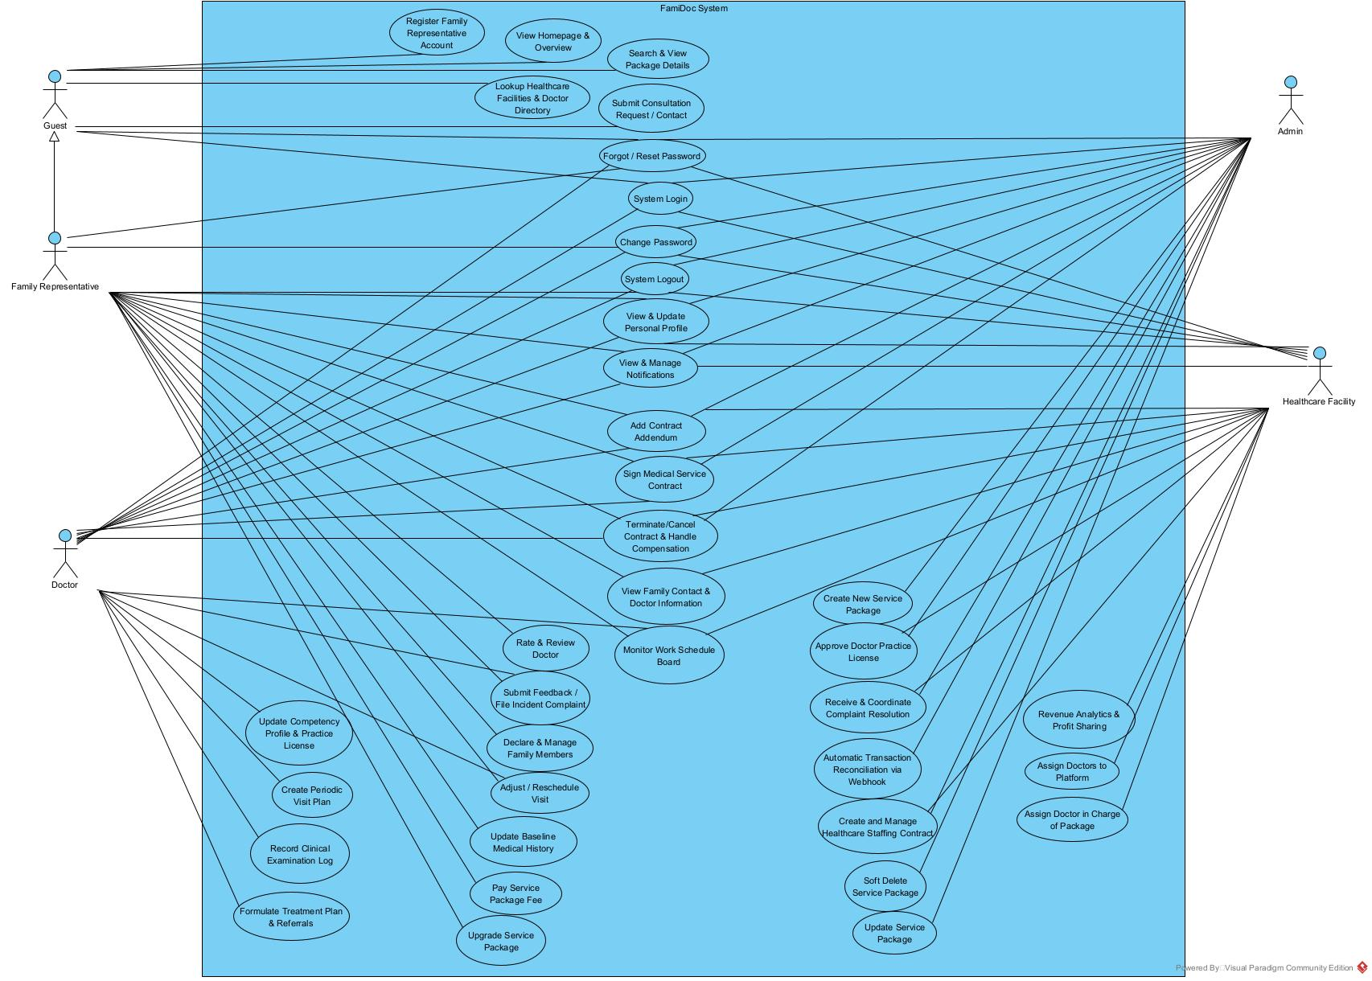

4.3.2 UCs for Guest
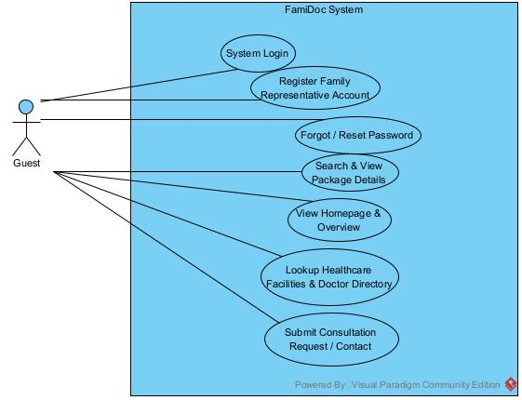

4.3.3 UCs for Family Representative
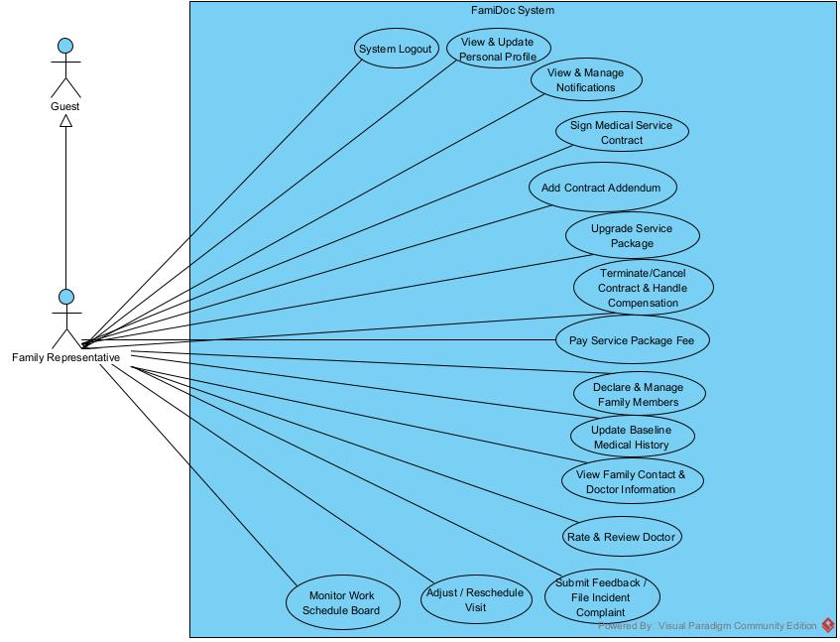

4.3.4 UCs for Doctor
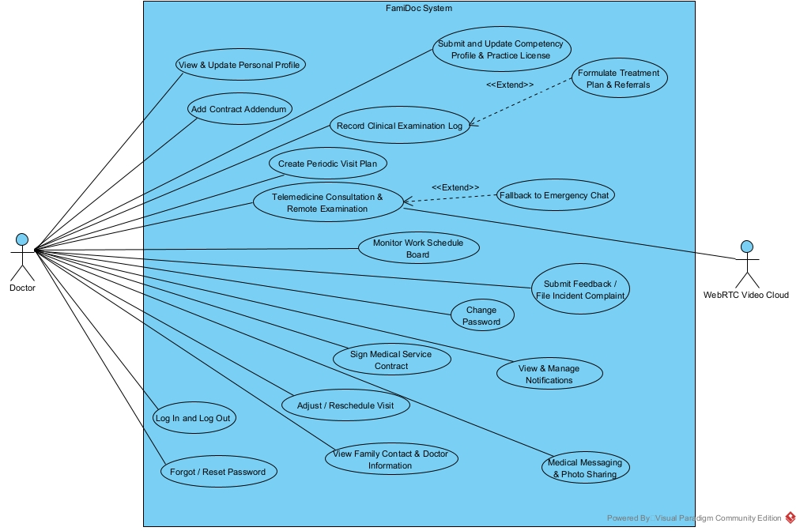

4.3.5 UCs for Admin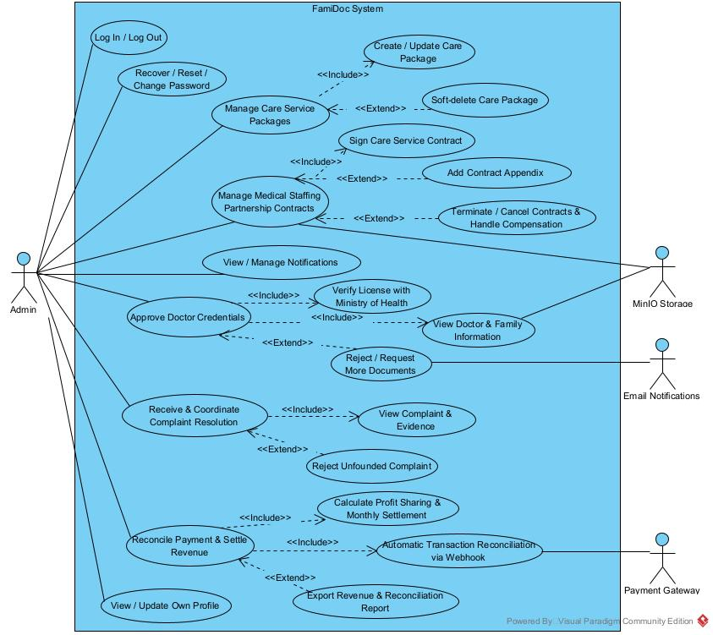

4.3.6 UCs for Healthcare Facility
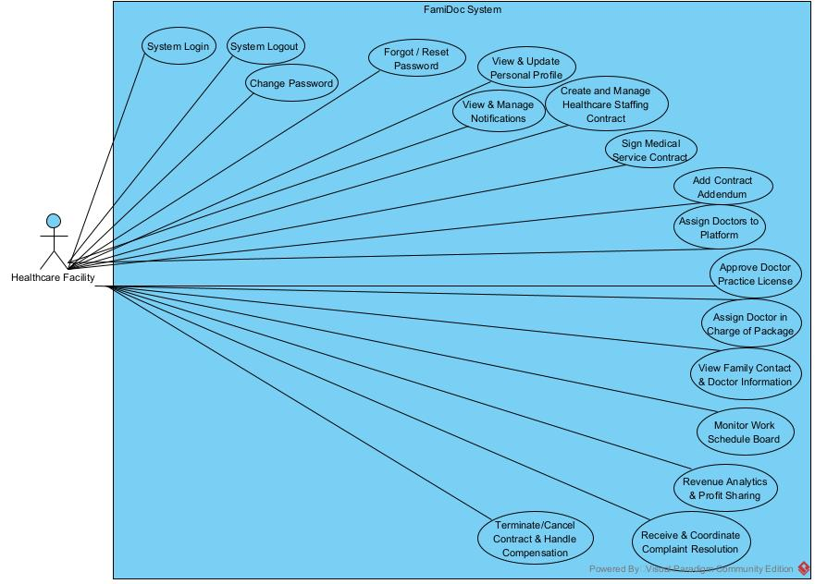

4.4 Permission Matrix
Full = unrestricted · Restricted = conditions apply (see footnotes) · No = denied
Entity | Action | Guest | Family Rep | Doctor | Facility | Admin
User Account | Register account (UC-01) | Full | No | No | No | No
User Account | Authenticate / Log In (UC-02) | Full | Full | Full | Full | Full
User Account | Reset / Change Password (UC-04, UC-05) | Full | Full | Full | Full | Full
User Account | Deactivate / Suspend User | No | No | No | No | Full
Public Portal | View Landing Page & Info (UC-06) | Full | Full | Full | Full | Full
Public Portal | Search Packages & Directory (UC-07, UC-08) | Full | Full | Full | Full | Full
Public Portal | Submit Inquiry / Lead (UC-09) | Full | Full | No | No | No
Healthcare Facility | Register / Onboard Facility | No | No | No | Full | Full
Healthcare Facility | Update Facility Profile & Hotline | No | No | No | Full | Full
Healthcare Facility | Verify & Approve Facility Accreditation | No | No | No | No | Full
Doctor Profile | Initialize Doctor Profile (UC-20) | No | No | No | Full | No
Doctor Profile | Upload & Update CCHN Dossier (UC-21) | No | No | Full | No | No
Doctor Profile | Facility Tier-1 Verification (UC-22) | No | No | No | Full | No
Doctor Profile | Admin Tier-2 Activation (UC-22) | No | No | No | No | Full
Doctor Profile | View Doctor Directory & Dossier | Full | Full | Full | Full | Full
Service Package | Create / Update Package (UC-12, UC-13) | No | No | No | No | Full
Service Package | Soft-Delete / Deprecate Package (UC-14) | No | No | No | No | Full
Service Package | Browse & View Package Catalog | Full | Full | Full | Full | Full
Family Household | Register & Update Household Profile (UC-24) | No | Full | No | No | Restricted [4]
Family Member (Patient) | Add / Edit Dependent Patient (UC-24) | No | Full | No | No | Restricted [4]
Family Member (Patient) | Update Health History & Allergies (UC-25) | No | Full | Restricted [3] | No | Restricted [4]
Family Member (Patient) | View Family Profile & Contact (UC-26) | No | Full | Restricted [3] | Restricted [7] | Full
Medical Contract | Create Institutional Supply Contract (UC-15) | No | No | No | Full | Full
Medical Contract | Initialize & Sign 4-Party Contract (UC-16) | No | Full | Full | Full | Full
Medical Contract | Assign Doctor to Contract (UC-23) | No | No | No | Full | Restricted [4]
Medical Contract | Add Contract Appendix / Extension (UC-17) | No | Full | Restricted [3] | Restricted [7] | Full
Medical Contract | Upgrade Service Package (UC-18) | No | Full | No | Restricted [7] | Full
Medical Contract | Terminate Contract & Indemnity (UC-19) | No | Restricted [8] | No | Restricted [8] | Full
Invoice & Payment | Pay Package Fee via VietQR/Gateway (UC-33) | No | Full | No | No | No
Invoice & Payment | Auto Webhook Reconciliation (UC-34) | No | No | No | No | Full
Invoice & Payment | View Payment Receipts & Invoices | No | Full | No | Restricted [7] | Full
Invoice & Payment | Revenue Sharing & Disbursement (UC-35) | No | No | Restricted [3] | Full | Full
Encounter Schedule | Schedule Periodic Home/Tele Visit (UC-27) | No | No | Full | Restricted [7] | Restricted [4]
Encounter Schedule | Reschedule Consultation Visit (UC-28) | No | Restricted [5] | Full | Restricted [7] | Restricted [4]
Encounter Schedule | View Master Timetable / Calendar (UC-29) | No | Restricted | Full | Full | Full
Encounter Schedule | Conduct Virtual Telemedicine (UC-32) | No | Full | Full | No | No
Clinical EMR | Document Encounter Notes & Vitals (UC-30) | No | No | Full | No | No
Clinical EMR | Finalize & Digitally Sign SOAP Record (UC-30) | No | No | Full | No | No
Clinical EMR | View EMR History & Vital Signs | No | Full | Restricted [3] | Restricted [7] | Restricted [4]
Clinical EMR | Export EMR Report for Direct Visit (UC-26) | No | No | Restricted [3] | Full | Restricted [4]
Prescription | Issue & Digitally Sign E-Prescription (UC-31) | No | No | Full | No | No
Prescription | View E-Prescription & QR Code | No | Full | Restricted [3] | Restricted [7] | Restricted [4]
Prescription | Create Hospital Referral Order (UC-31) | No | No | Full | Full | Restricted [4]
Feedback & Rating | Submit Doctor Review & Star Rating (UC-36) | No | Restricted [6] | No | No | No
Feedback & Rating | View Doctor Public Ratings | Full | Full | Full | Full | Full
Dispute & Complaint | Submit Service Incident Complaint (UC-37) | No | Full | Full | No | No
Dispute & Complaint | Investigate & Arbitrate Dispute (UC-38) | No | Restricted | Restricted | Full | Full
System Administration | Configure Global Parameters (UC-24 in sys) | No | No | No | No | Full
System Administration | Access Security Audit Logs | No | No | No | No | Full
System Administration | Broadcast Push Notifications (UC-11) | No | No | No | Restricted [7] | Full
Footnotes: Conditions for Restricted Access
[3] Doctor's Medical Access: Restricted to patients who have an active primary care contract assigned to the doctor, or during an ongoing consultation encounter conducted by the covering doctor. Doctors cannot view EMRs or prescribe medications for unassigned patients.
[4] Admin's Audit Access: Restricted to Read-Only mode. Admins are permitted to view sensitive medical records or member profiles only when investigating an active formal dispute/complaint (UC-38) or performing automated compliance audit.
[5] Appointment Cancellation / Reschedule: Restricted by the minimum advance notification threshold ENCOUNTER_RESCHEDULE_MIN_HOURS (CFG-07, default 4 hours). Family Representatives cannot reschedule an appointment if within the lockout window.
[6] Review & Rating: Restricted to post-encounter. Family Representatives can only submit a rating exactly once, and only after the clinical encounter status has transitioned to 'Completed'.
[7] Healthcare Facility Access: Restricted to doctors, contracts, and patient encounters affiliated with or assigned through that specific Healthcare Facility (UC-26, UC-29). The facility cannot access patient records or contracts of competitor facilities.
[8] Contract Termination: Restricted to agreed conditions specified in the legal agreement (UC-19), subject to mutual concurrence, indemnity calculations, and platform admin approval.

5. System Functionalities

5.1 Screen Inventory

a. Screen Flow
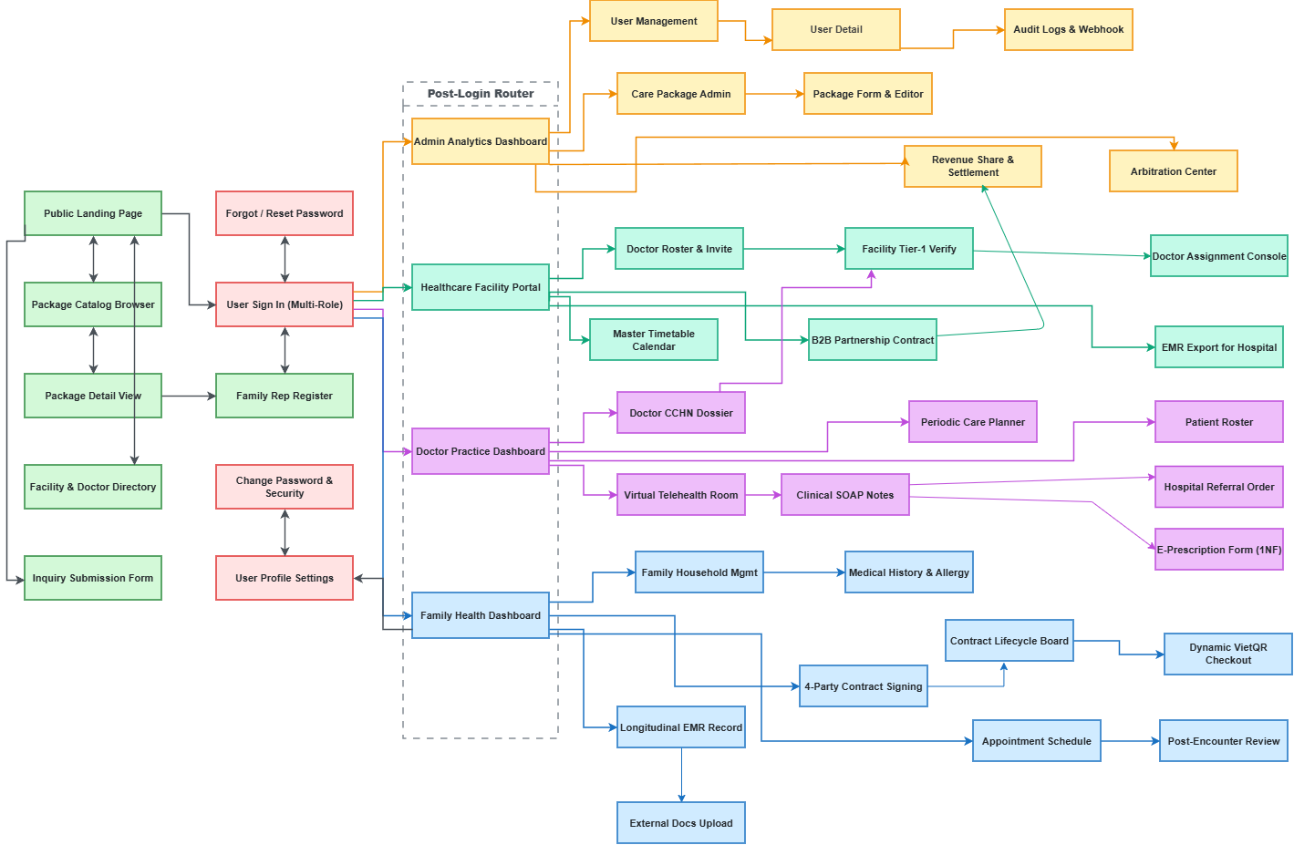

b. Screen List
# | Screen Name | Feature | Description
1 | Family Representative Register | FT-01: Authentication & Access Control | Household representative registration with full name, E.164 phone number, email, and password; OTP SMS/Email verification to activate account (UC-01).
2 | User Sign In (Multi-Role) | FT-01: Authentication & Access Control | Unified secure authentication for all 5 actors via credentials or OTP; automatic role-based redirection to corresponding portal (UC-02).
3 | Forgot / Reset Password | FT-01: Authentication & Access Control | Password recovery flow initiating secure OTP or email reset link verification (UC-04).
4 | User Account & Security Settings | FT-01: Authentication & Access Control | Personal account settings, credential updates, active session termination, and two-factor authentication configuration (UC-05).
5 | Public Landing Page | FT-02: Public Portal & Discovery | Public portal introducing family doctor healthcare model, primary care standards, and accredited partner hospital network (UC-06).
6 | Package Catalog Browser | FT-02: Public Portal & Discovery | Search and filter healthcare packages by clinical needs, family size, home visit quotas, and transparent subscription fees (UC-07).
7 | Package Detail View | FT-02: Public Portal & Discovery | Detailed breakdown of package benefits: routine home visits, tele-consultation quota, periodic lab tests, and sample contract terms (UC-07).
8 | Facility & Doctor Directory | FT-02: Public Portal & Discovery | Public directory of certified partner healthcare facilities and doctors with clinical specialties, CCHN credentials, and verified star ratings (UC-08).
9 | Inquiry & Lead Submission Form | FT-02: Public Portal & Discovery | Public contact form for prospective families to request personalized package recommendations from customer care (UC-09).
10 | User Profile Management | FT-03: Common Utilities | Role-tailored profile view: Family Rep contact updates, Doctor professional bios, and Facility institutional profile info (UC-10).
11 | Multi-Channel Notification Hub | FT-03: Common Utilities | Aggregated inbox for in-app alerts and notifications: appointment reminders, contract progress, payment due notices, and EMR updates (UC-11).
12 | Care Package Admin Dashboard | FT-04: Care Package Administration | Centralized catalog registry for platform administrators: manage package status (Draft, Active, Deprecated), and active contract metrics (UC-12).
13 | Care Package Form & Editor | FT-04: Care Package Administration | Form to configure service packages: validity duration (6-12 months), base price, periodic visit quota, max dependent members, and out-of-package fee schedules (UC-12, UC-13, UC-14).
14 | B2B Facility Partnership Contract | FT-05: Contract & Legal Management | Contract builder and digital signing interface for institutional manpower agreements between Platform and Healthcare Facilities with revenue share rates (UC-15).
15 | 4-Party Contract Signing Flow | FT-05: Contract & Legal Management | Sequential 4-party digital contract signing wizard: Family Rep & Admin sign -> Facility assigns doctor & signs -> Doctor signs acceptance (UC-16).
16 | Contract Lifecycle Status Board | FT-05: Contract & Legal Management | Comprehensive contract overview displaying validity dates, assigned family doctor, remaining consultation quotas, and digitally signed PDF download (UC-16).
17 | Contract Appendix & Package Upgrade | FT-05: Contract & Legal Management | Interface to execute contract addendums for quota expansions, term extensions, or upgrading to premium care plans (UC-17, UC-18).
18 | Contract Termination & Indemnity | FT-05: Contract & Legal Management | Formal contract cancellation workflow with mutual dispute review, automatic penalty calculations, and refund ledger (UC-19).
19 | Facility Doctor Roster & Invitation | FT-06: Medical Personnel Onboarding | Healthcare Facility console to register affiliated physicians, input clinical departments, and trigger automatic account onboarding emails (UC-20).
20 | Doctor Credential & CCHN Dossier | FT-06: Medical Personnel Onboarding | Doctor workspace to upload scanned CCHN practice licenses, specialist diplomas, and 3+ month Family Medicine training certificates (UC-21).
21 | Doctor License Dual-Approval Portal | FT-06: Medical Personnel Onboarding | Two-tier credential verification console: Tier-1 Facility institutional verification and Tier-2 Admin National Registry accreditation (UC-22).
22 | Doctor Contract Assignment Console | FT-06: Medical Personnel Onboarding | Healthcare Facility dispatch screen to evaluate doctor workload panel capacity (<= 30 households) and assign primary attending doctors to active family contracts (UC-23).
23 | Family Household Management | FT-07: Family Health Profile | Household management console to register and maintain family dependent profiles (children, elderly parents, spouse) and emergency contact numbers (UC-24).
24 | Patient Medical History & Allergies | FT-07: Family Health Profile | Baseline health intake form recording chronic conditions, drug/food allergies, blood types, surgical history, and lifestyle factors (UC-25).
25 | Family Administrative Lookup | FT-07: Family Health Profile | Administrative and clinical dispatch lookup showing home address and emergency phone numbers for urgent response (UC-26).
26 | Periodic Visit Care Planner | FT-08: Scheduling & Workload Balancing | Doctor scheduling interface to establish periodic home visits, clinic appointments, or telehealth checkups based on package quotas (UC-27).
27 | Encounter Reschedule Request | FT-08: Scheduling & Workload Balancing | Encounter rescheduling interface enforcing the 4-hour advance notice window (CFG-07) with automated push and email notifications (UC-28).
28 | Family Appointment Schedule | FT-08: Scheduling & Workload Balancing | Family appointment calendar displaying upcoming doctor visits, assigned physician, consultation venue, and pre-visit preparation checklists.
29 | Facility Master Timetable & Conflict Control | FT-08: Scheduling & Workload Balancing | Facility-wide calendar consolidating all off-site doctor visits to prevent scheduling conflicts with internal hospital on-call shifts (UC-29).
30 | Virtual Telehealth Consultation Room | FT-09: Clinical Encounter & EMR | Virtual examination room featuring encrypted WebRTC video calling, real-time clinical chat, and lesion photo sharing (UC-32).
31 | Clinical Encounter SOAP Documentation | FT-09: Clinical Encounter & EMR | Standardized SOAP clinical chart: Chief Complaint, Objective Examination, Composite Vital Signs recording, ICD-10 coding, and tamper-proof digital sign-off (UC-30).
32 | E-Prescription Form (1NF Standard) | FT-09: Clinical Encounter & EMR | Itemized e-prescription writer: medication name, dosage form, total quantity, unit, intake frequency, and treatment days conforming to Circular 04/2022/TT-BYT (UC-31).
33 | Hospital Referral Order Generator | FT-09: Clinical Encounter & EMR | Clinical referral dispatch tool generating formal transfer slips with summarized EMR diagnostic extracts for higher-tier partner hospitals (UC-31).
34 | Patient Longitudinal EMR Health Record | FT-09: Clinical Encounter & EMR | Longitudinal health record repository: chronologically indexed EMR encounters, vital trend charts, prescription history, and clinical report export (UC-26).
35 | External Medical Records Upload | FT-09: Clinical Encounter & EMR | Family portal to upload diagnostic test results, ultrasound images, and discharge papers from external hospitals for doctor review.
36 | Dynamic VietQR Checkout | FT-10: Financial Billing & Settlement | Payment checkout generating dynamic VietQR codes for package retainers or out-of-package encounter fees with a 15-minute expiration countdown (UC-33).
37 | Billing & Payment History Ledger | FT-10: Financial Billing & Settlement | Invoice and transaction repository providing official electronic receipts, payment statuses, and tax invoice download.
38 | Automated Webhook Audit & Reconciliation | FT-10: Financial Billing & Settlement | Admin monitoring console tracking banking/gateway Webhook callbacks, automated transaction matching, and instant contract activation (UC-34).
39 | B2B Revenue Share & Settlement Console | FT-10: Financial Billing & Settlement | Monthly accounting dashboard: aggregates completed contracts, deducts VAT and 15% platform fee (CFG-03), and generates net payout disbursements for Facilities (UC-35).
40 | Post-Encounter Doctor Review | FT-11: Ratings & Dispute Resolution | Post-consultation rating screen (1-5 stars) and qualitative feedback form unlocked only after clinical encounter status is 'Completed' (UC-36).
41 | Dispute & Incident Report Filing | FT-11: Ratings & Dispute Resolution | Formal complaint filing screen for service breaches (missed appointments, unauthorized fee collection, non-compliance) with evidence upload (UC-37).
42 | Dispute Resolution & Arbitration Center | FT-11: Ratings & Dispute Resolution | Joint arbitration workspace for Platform Admin and Healthcare Facility to examine audit logs, negotiate solutions, issue penalties, or refund families (UC-38).

5.2 External API Inventory
# | API Name | Calling Path | Description
1 | VietQR & Bank Payment Gateway | FamiDoc → Payment Gateway / Napas 247 | Generates dynamic VietQR payloads and payment links with embedded contract/invoice codes and exact amounts for service package subscriptions (UC-33) and out-of-package clinical consultation fees.
2 | Payment Webhook Callback (IPN) | Payment Gateway → FamiDoc | Receives cryptographically signed (HMAC-SHA256) Instant Payment Notification (IPN) webhooks from banking partners to automatically reconcile invoices and activate running contracts in real-time (UC-34).
3 | Telecom SMS OTP & Zalo ZNS Gateway | FamiDoc → Twilio / Zalo Cloud / eSMS | Dispatches 6-digit numeric OTP authentication codes for family representative phone registration (UC-01), secure password recovery (UC-04), and doctor initial account activation notices (UC-20).
4 | Telehealth WebRTC Cloud Service | FamiDoc ↔ WebRTC Provider (LiveKit / Agora) | Provides encrypted low-latency peer-to-peer audio/video streaming, session signaling, and STUN/TURN media relay capabilities for virtual telemedicine consultations and clinical lesion photo transmissions (UC-32).
5 | National E-Prescription Portal (donthuocquocgia.vn) | FamiDoc → National E-Prescription Portal (MoH) | Interfaces directly with the Ministry of Health National Prescription Portal to obtain unique accredited electronic prescription codes (RX-YYYY-XXXXXX) conforming to Circular 04/2022/TT-BYT & Circular 27/2021/TT-BYT (UC-31).
6 | Remote PKI Digital Signature Service | FamiDoc → CA Provider (VNPT / Viettel / FPT) | Executes legal digital signature signing (CMS/CAdES standards) for sequential 4-party medical service contracts (UC-16), attending physician EMR sign-offs (UC-30), and official electronic prescriptions (UC-31).
7 | Encrypted Cloud Object Storage | FamiDoc → Amazon S3 / MinIO | Provides secure, encrypted at-rest (AES-256) blob storage for sensitive healthcare documents: digitally signed contract PDFs, scanned doctor CCHN practicing certificates (UC-21), and external hospital diagnostic lab records (UC-26).

5.3 Background Job Inventory
ID | Job Name | Group | Description
JOB-01 | Unpaid Invoice & Booking Timeout Worker | Worker Queue | Runs continuously every 1 minute (* * * * *); automatically cancels pending VietQR invoices and releases reserved consultation slots if payment is not completed within UNPAID_INVOICE_TIMEOUT (15 minutes, CFG-05).
JOB-02 | Contract Expiration & Renewal Monitor | Scheduled | Runs daily at 07:00 AM (0 7 * * *); scans active medical contracts expiring within 15 days to issue automated renewal alerts and package upgrade recommendations to family representatives (UC-17, UC-18).
JOB-03 | Encounter Notification & Reschedule Guard | Scheduled | Runs every 30 minutes (*/30 * * * *); checks upcoming appointments within 24 hours and 2 hours to push automated reminders; locks self-service rescheduling if the start time is within ENCOUNTER_RESCHEDULE_MIN_HOURS (4 hours, CFG-07).
JOB-04 | Master Timetable Conflict Detection | Scheduled | Runs daily at 23:00 PM (0 23 * * *); cross-examines doctors' off-site home consultation schedules against affiliated Healthcare Facility hospital on-call rosters, generating conflict warnings for facility coordinators (UC-29).
JOB-05 | Draft Clinical EMR Auto-Locking Guard | Scheduled | Runs hourly (0 * * * *); identifies clinical EMR records remaining in Draft status exceeding 24 hours post-encounter; issues urgent digital signing alerts to attending physicians and executes tamper-evident locking under ISO 27799 (BR-10).
JOB-06 | Expired E-Prescription Invalidation Job | Scheduled | Runs daily at 00:05 AM (5 0 * * *); marks electronic prescriptions issued beyond E_RX_VALIDITY_DAYS (30 days, CFG-04) that have not been dispensed as Expired, preventing unauthorized delayed pharmacy purchasing (BR-13).
JOB-07 | Monthly B2B Revenue Settlement Batch | Scheduled | Runs on the 5th of each month at 01:00 AM (0 1 5 * *, CFG-10); aggregates completed contract revenues, deducts VAT and 15% platform commission (CFG-03), and compiles itemized disbursement statements for partner Healthcare Facilities (UC-35, BR-14).
JOB-08 | Asynchronous PDF & E-Signature Generator | Worker Queue | Event-driven queue worker triggered upon contract signing or EMR sign-off; renders standardized PDF/A documents, embeds cryptographic CMS digital signatures, and uploads to encrypted storage (UC-16, UC-30).

II. Use Case Specifications

1. Feature: Healthcare Service Package Management

1.1 Create & Configure Care Service Package
Primary Actors | System Administrator (ACT-05: Admin) | Secondary Actors | None
Description | As a System Administrator, I want to create and configure comprehensive healthcare care service packages so that they can be published on the public portal for family subscription and establish service quotas, physician criteria, and legal pricing parameters.
Preconditions | Administrator has successfully authenticated with full platform administration privileges (ACT-05: Admin).
Normal Flow | 1. Administrator navigates to Service Package Management screen (SCR-12) and clicks "Create Care Package".  2. System renders the Package Configuration Form (SCR-13).  3. Administrator inputs package quota details: Package Name, unique Package Code (PackageCode), validity duration (6 months, 12 months), maximum covered household members (MaxMembers, e.g., 4-6 members), quota of scheduled in-home visits (home_visit_quota), quota of remote telehealth consultations (telehealth_quota), and base retainer subscription price (BasePrice).  4. Administrator configures physician qualification criteria (specialization, minimum years of clinical practice, CCHN credentials) and out-of-quota unit pricing fees.  5. Administrator clicks "Save & Activate".  6. The system validates data integrity, stores the package record in Active status, and publishes the package to the Public Portal (SCR-06).
Alternative Flows | - Save as Draft: At Step 5, Administrator selects "Save Draft". The system persists packages in Draft status (hidden from public registration).  - Validation Error: If duplicate Package Code or negative price/quota is detected, the system displays a validation error alert and keeps Administrator on the editing form.
Postconditions | A new healthcare service package is persisted with Active or Draft status in the system repository and available for family contracting.

2. Feature: Contract & Legal Management

2.1 Establish & Manage B2B Manpower Supply Contract
Primary Actors | Medical Facility Representative (ACT-04: Medical Facility Representative) | Secondary Actors | System Administrator (ACT-05: Admin)
Description | As a Medical Facility Representative, I want to establish and sign a B2B Manpower Supply Agreement with FamiDoc so that my affiliated physicians can legally provide family doctor care services under the platform governance framework.
Preconditions | - A medical facility is registered with a validated operational license (operating_license).  - Facility Representative is authenticated with facility manager authority.
Normal Flow | 1. Facility Representative navigates to B2B Partner Contract Screen (SCR-15) and clicks "Initiate Partnership Contract".  2. The system generates standardized legal B2B agreement drafts defining: revenue split ratio (85% to Facility, 15% platform commission per CFG-05), dispute resolution protocols, and accredited physician roster.  3. Facility Representative reviews contractual clauses and attaches certified institutional operating license and credentials.  4. Facility Representative submits proposal for administrative appraisal.  5. System notifies Platform Administrator. Admin reviews facility credentials, clinical scope, and counter-signs contracts via Remote Digital Signature (API-06).  6. Facility Representative logs in, reviews approved terms, and executes institutional digital signature via OTP / Token (API-06).  7. The system validates cryptographic signatures, stores immutable PDF in secure storage (API-07), transitions contract status to Active, and unlocks physician dispatching permissions for the facility.
Alternative Flows | - Admin Rejection / Clarification: Admin detects incomplete credentials, rejects proposal with explanatory notes. Status becomes Draft/Needs Revision.  - Digital Signature Failure: If Remote Signing fails (API-06), system logs transaction error, preserves contract in Pending Signature, and prompts user to retry.
Postconditions | B2B Manpower Supply Contract transitions to Active; facility is authorized to assign doctors to family retainer subscriptions.

2.2 Execute 4-Party Healthcare Service Retainer Contract
Primary Actors | Family Representative (ACT-02: Family Representative) | Secondary Actors | Medical Facility Representative (ACT-04), Primary Care Physician (ACT-03), System Administrator (ACT-05)
Description | As a Family Representative, I want to sign a legally binding 4-Party Retainer Medical Service Contract (Family, Facility, Doctor, Platform) so that my household receives continuous, dedicated primary healthcare services.
Preconditions | - Family Representative is logged in with a verified citizen profile and registered household members.  - Selected Care Package is in Active status.
Normal Flow | 1. Family Representative reviews care package details and clicks "Sign Healthcare Retainer Contract" (SCR-14).  2. The system generates a draft 4-Party Electronic Retainer Contract (MEDICAL_CONTRACT) with a unique ContractCode, legally binding: Family Representative, Medical Facility, Assigned Doctor, and Platform Provider (Admin).  3. Family Representative reviews terms, commitments, and inputs SMS/Email OTP to execute digital signature (API-06).  4. The system applies Platform digital signature (Admin) and dispatches contracts to the affiliated Medical Facility.  5. Facility Representative reviews the contract, confirms administrative capacity, and assigns an accredited in-house physician (ACT-03) with active panel capacity (active_panel_count < CFG-01).  6. Assigned Doctor receives dispatch alert, reviews family clinical profiles, and electronically accepts caregiving responsibilities (SCR-16).  7. System transitions contract status to Pending Payment and navigates Family Representative to Invoice Settlement screen (SCR-36).
Alternative Flows | - Physician Capacity Overload (BR-04): If the assigned doctor has reached the capacity limit (active_panel_count >= 30), the system blocks the assignment and prompts the Facility to select an alternate physician.  - Contract Cancellation: The Family Representative may cancel contract drafting before signature; the status transitions to Cancelled.
Postconditions | A legally compliant 4-Party Retainer Contract is instantiated in Pending Payment status awaiting VietQR settlement.

2.3 Contract Addendum & Subscription Renewal
Primary Actors | Family Representative (ACT-02: Family Representative) | Secondary Actors | Primary Care Physician (ACT-03), Medical Facility Representative (ACT-04), Admin (ACT-05)
Description | As a Family Representative, I want to purchase additional encounter credits or extend contract duration via Contract Addenda so that our ongoing family care remains uninterrupted.
Preconditions | The existing contract is in Active or Expiring Soon status.
Normal Flow | 1. Family Representative accesses Contract Details screen (SCR-16) and selects "Renew / Purchase Addendum".  2. Family chooses option: Term Renewal (6 or 12 months) or Out-of-Quota Encounter Addendum (additional home visits or telehealth sessions).  3. The system creates a Contract Addendum draft (CONTRACT_APPENDIX) linked to the master contract.  4. Family Representative confirms addendum terms and signs electronically via OTP.  5. System dispatches addendum update notifications to Facility and Primary Care Physician.  6. Family Representative settles payment via dynamic VietQR code; system automatically increments quota credits (remaining_home_visits, remaining_telehealth) and extends expiry date.
Alternative Flows | - Expired Contract Renewal: If the master contract has already expired, the system creates a renewal contract linked to prior clinical history while resetting quotas.  - Payment Timeout: If the addendum payment is not received within 15 minutes (CFG-05), JOB-01 sets the Invoice to Expired and automatically cancels the addendum or upgrade request. The current active contract remains completely unchanged.
Postconditions | Master contract quotas and validity period updated; electronic addendum document stored in PDF repository.

3. Feature: Medical Personnel & Onboarding

3.1 Two-Tier Doctor Credential & CCHN License Verification
Primary Actors | Medical Facility Representative (ACT-04), System Administrator (ACT-05) | Secondary Actors | Primary Care Physician (ACT-03)
Description | As a Medical Facility and System Administrator, we want to perform a 2-tier verification of doctor practice certificates (CCHN) so that only legally licensed physicians can provide clinical consultations on FamiDoc.
Preconditions | Doctor has registered an account and submitted scanned CCHN certificates and family medicine training diplomas.
Normal Flow | 1. Tier-1 Verification (Medical Facility): Facility Representative reviews pending doctor profiles (SCR-21), cross-checks CCHN numbers, labor contracts, and verifies physician identity. Facility clicks "Verify Tier-1".  2. System sets profile status to Facility Verified and forwards application to Platform Administration queue.  3. Tier-2 Verification (Admin): Administrator conducts post-audit against National Healthcare Practitioner Registry, verifying CCHN validity, scope of practice (Family Medicine / General Medicine), and mandatory 3+ months family medicine certification.  4. Administrator clicks "Approve & Activate".  5. The system marks doctor status as Verified, assigns physician permissions, and sends email notification with activation confirmation (API-03).
Alternative Flows | - Tier-1 Rejection: Facility rejects profile due to incomplete documentation; doctor receives notification to resubmit credentials.  - Tier-2 Rejection: Admin detects invalid CCHN or credential discrepancies; status transitions to Rejected with formal audit remarks.
Postconditions | Physician is certified and permitted to take family care assignments (active_panel_count initialized to 0).

3.2 Assign Primary Care Physician with Panel Capacity Control
Primary Actors | Medical Facility Representative (ACT-04: Facility Representative) | Secondary Actors | Primary Care Physician (ACT-03)
Description | As a Medical Facility Representative, I want to assign a dedicated doctor to a family retainer contract while strictly enforcing panel capacity limits so that doctors do not experience workload burnout and quality of care is maintained.
Preconditions | The retainer contract is signed by the family; the doctor is verified and belongs to the medical facility.
Normal Flow | 1. Facility Representative opens Doctor Assignment screen (SCR-22) for a newly signed contract.  2. System filters and displays list of eligible affiliated doctors with real-time panel capacity metrics (active_panel_count).  3. Facility Representative selects a qualified physician whose current panel is below the ceiling (active_panel_count < CFG-01: 30 households).  4. Facility Representative clicks "Confirm Assignment".  5. The system associates DoctorID with the contract, increments doctor's active_panel_count by 1, and dispatches notification to the physician.  6. Doctor accepts assignment and initial family health onboarding is scheduled.
Alternative Flows | - Capacity Limit Reached (BR-04): If the facility attempts to assign a doctor with 30 active households, the system blocks the action with a warning: "Doctor panel limit reached (30/30). Please select another doctor."  - Doctor Reassignment (BR-03): When a doctor is reassigned, the previous doctor's counter is decremented by 1, and the new doctor's counter is incremented by 1.
Postconditions | Dedicated doctor assigned to family contract; doctor workload panel counters updated.

4. Feature: Family Health Profile Management

4.1 Register & Manage Household Members
Primary Actors | Family Representative (ACT-02: Family Representative) | Secondary Actors | Household Members (ACT-01), Primary Care Physician (ACT-03)
Description | As a Family Representative, I want to register and manage profiles of all household members so that their individual health records and medical timelines are tracked longitudinally.
Preconditions | Family Representative is authenticated; the contract has an active member quota (MaxMembers).
Normal Flow | 1. Family Representative navigates to the Household Members Management screen (SCR-23).  2. User clicks "Add Member" (SCR-24).  3. User inputs member demographic details: Full Name, Date of Birth, Gender, Relationship (Spouse, Child, Parent), Citizen ID / Birth Certificate, and emergency contact.  4. User enters baseline medical history: known drug/food allergies, chronic conditions (Hypertension, Diabetes, Asthma), and regular medications.  5. User clicks "Save Member Profile".  6. System verifies total member count does not exceed package ceiling (MaxMembers, CFG-08), creates member record, and generates dedicated EHR Timeline (SCR-25).
Alternative Flows | - Member Quota Exceeded (BR-01): If a household already has maximum permitted members (e.g., 6/6), the system prompts users to purchase member extension addendum (UC-17).  - Edit / Archive Member: User updates existing member's baseline vitals or allergy data; system preserves clinical audit logs.
Postconditions | Household member added with independent EHR profile; accessible to assigned physician.

5. Feature: Scheduling & Workload Balancing

5.1 Plan Routine Periodic Home & Telehealth Encounters
Primary Actors | Primary Care Physician (ACT-03: Primary Care Physician) | Secondary Actors | Family Representative (ACT-02)
Description | As a Primary Care Physician, I want to proactively plan scheduled periodic home visits and telehealth check-ins throughout the contract duration so that routine preventive care is systematically delivered.
Preconditions | Contract is Active; physician is assigned to the household.
Normal Flow | 1. Physician accesses Periodic Care Planner (SCR-26) and selects assigned family.  2. Physician reviews care package encounter quota (e.g., 4 home visits, 6 telehealth sessions per year) and distributes encounters across timeline.  3. For each encounter (ENCOUNTER), the physician specifies: Scheduled Date, Time Window, Encounter Type (HomeVisit or Telehealth), Target Members, and Clinical Care Objectives.  4. Physician clicks "Publish Care Plan".  5. System records encounters, populates family care calendar (SCR-28), and sends push notifications to Family Representative (SCR-27).
Alternative Flows | - Rescheduling Request: Family or physician requests time modification before the lock deadline (CFG-07: 4h prior); system allows adjusting time slot without consuming quota.  - Late Cancellation: If cancelled within 24 hours of encounter, the system applies penalty rules per BR-08 and logs the reason.
Postconditions | Clinical care roadmap established with synchronized calendar appointments.

5.2 Facility Master Timetable & Conflict Balancing
Primary Actors | Medical Facility Representative (ACT-04: Facility Representative) | Secondary Actors | Primary Care Physician (ACT-03)
Description | As a Medical Facility Coordinator, I want to monitor the master schedule of all affiliated doctors and balance hospital shifts against home visits so that scheduling conflicts and overlapping commitments are prevented.
Preconditions | The medical facility coordinator is authenticated; doctors have populated schedules.
Normal Flow | 1. Facility Coordinator opens Master Timetable & Conflict Monitor (SCR-29).  2. The system displays a multi-doctor timeline grid showing hospital on-duty shifts, scheduled home visits, and telehealth sessions.  3. The system runs real-time collision detection. If no time conflicts exist, slots are marked green (Balanced).  4. Facility monitors encounter completion rates and clinical performance metrics.
Alternative Flows | - Conflict Detected (BR-04): A doctor schedules a home visit during an assigned hospital shift or with insufficient transit buffer. System flags slot with red warning alert: "Schedule Collision Detected: Doctor has hospital duty from 08:00 to 12:00".  - Shift Balancing / Reassignment: Coordinator adjusts hospital shift roster or triggers temporary substitution of the home visit.
Postconditions | Master clinic schedule optimized with zero unresolved scheduling collisions.

6. Feature: Clinical Encounter, EMR & Prescriptions

6.1 Document SOAP Clinical Record & ISO 27799 Tamper-Proof Lock
Primary Actors | Primary Care Physician (ACT-03: Primary Care Physician) | Secondary Actors | Patient / Household Member (ACT-01), Family Representative (ACT-02)
Description | As an attending physician, I want to document comprehensive SOAP clinical records during patient encounters and apply digital signing with ISO 27799 tamper-proof locking so that clinical integrity and legal accountability are guaranteed.
Preconditions | Encounter is currently ongoing or concluded; physician has active credentials.
Normal Flow | 1. Physician opens SOAP EMR Documentation screen (SCR-31) linked to current encounter.  2. Physician records clinical data according to standardized SOAP format:  - S (Subjective): Chief complaint, symptoms, anamnesis.  - O (Objective): Vital signs (Blood Pressure, Heart Rate, SpO2, Temperature), physical examination findings.  - A (Assessment): Primary diagnosis and differential diagnoses with ICD-10 coding (API-05).  - P (Plan): Treatment plan, clinical guidance, medication order, follow-up date.  3. The physician reviews documentation and clicks "Digitally Sign & Seal EMR".  4. The system calls Remote Signing Service (API-06), embeds physician's digital certificate timestamp, transitions status to Signed, and enforces ISO 27799 tamper-proof lock (preventing subsequent edits or deletions).  5. Audit log entry is generated; medical timeline updates with sealed clinical encounter record.
Alternative Flows | - Save Draft: Physician saves interim findings before finalizing; record remains in Draft state (editable within 24 hours).  - Post-Seal Addendum: If a physician must add post-encounter notes, the system prohibits editing original entries and requires creating an append-only Clinical Addendum with separate signature stamp.
Postconditions | Tamper-proof SOAP medical record sealed; viewable by family and authorized clinical team.

6.2 Issue 1NF National Electronic Prescription & Clinical Referral
Primary Actors | Primary Care Physician (ACT-03: Primary Care Physician) | Secondary Actors | Patient (ACT-01), External Pharmacy System
Description | As an attending physician, I want to issue normalized electronic prescriptions compliant with the National Prescription Portal (donthuocquocgia.vn) and generate referral letters when hospital escalation is required.
Preconditions | SOAP clinical record has verified primary diagnosis and ICD-10 code.
Normal Flow | 1. The physician clicks "Issue Electronic Prescription" (SCR-32) from EMR screen.  2. Physician inputs 1NF prescription line items: Drug active ingredient / brand name, dosage, administration route, frequency, duration, and quantity.  3. The system executes real-time drug interaction and allergy checks against patient EHR profile.  4. The physician confirms the medication list and clicks "Sign & Submit National Prescription".  5. The system transmits prescription payload to National Prescription Portal (API-05: donthuocquocgia.vn) and retrieves authoritative NationalPrescriptionID and QR barcode.  6. Prescription is published to the family portal (SCR-33) with 30-day dispensing validity.
Alternative Flows | - Clinical Escalation / Referral: If symptoms exceed primary care capabilities, the physician generates a Hospital Referral Letter (SCR-34) with a structured medical summary.  - Allergy / Interaction Alert: System flags severe contraindication (e.g., Penicillin allergy); physician must modify medication or input explicit clinical justification.
Postconditions | Normalized electronic prescription registered on National Portal; stored in patient's lifelong EHR timeline.

6.3 Encrypted WebRTC Telemedicine Consultation
Primary Actors | Primary Care Physician (ACT-03), Family Representative / Member (ACT-02 / ACT-01) | Secondary Actors | System Administrator (ACT-05)
Description | As a family member and doctor, we want to conduct real-time peer-to-peer encrypted video consultations so that remote medical advice can be delivered securely and conveniently.
Preconditions | Scheduled telehealth encounter time window is reached; both parties have camera and microphone permissions enabled.
Normal Flow | 1. At scheduled appointment time, Doctor and Family click "Join Virtual Consultation" from the appointment reminder (SCR-30).  2. The system initializes the WebRTC signaling channel (API-04), generating a secure, encrypted consultation room.  3. Doctor and Patient engage in two-way HD video/audio consultation.  4. Patients use in-call clinical chat to share high-resolution symptom photos or lab results.  5. The doctor inspects images, conducts anamnesis, and provides medical advice.  6. Call terminates; system automatically transitions doctor to SOAP EMR documentation screen (UC-30).
Alternative Flows | - Network Drop / Reconnect: System automatically attempts ICE reconnection; if connection drops, fallback to in-app clinical chat is provided.  - No-Show: If a patient or doctor fails to join within 15 minutes, the system marks the encounter as No-Show and triggers an alert per BR-08.
Postconditions | Telehealth encounter completed; call telemetry (duration, timestamp) recorded in encounter audit log.

7. Feature: Financial Billing, Payment & B2B Settlement

7.1 Dynamic VietQR Payment & Automated Webhook Reconciliation
Primary Actors | Family Representative (ACT-02: Family Representative) | Secondary Actors | Payment Gateway / Banking Switch (External System), System Administrator (ACT-05)
Description | As a Family Representative, I want to pay for healthcare packages via dynamic VietQR codes with automated webhook reconciliation so that services are activated instantly without manual proof-of-payment submission.
Preconditions | Retainer contract is in Pending Payment status; billing invoice is generated.
Normal Flow | 1. Family Representative accesses Invoice Payment screen (SCR-36).  2. System requests dynamic QR from Payment Gateway (API-01) with encoded invoice ID, exact amount, and cryptographic checksum.  3. System renders dynamic VietQR code on screen with a 15-minute countdown timer.  4. Family Representative opens mobile banking app, scans QR, and confirms payment transfer.  5. Banking Switch processes transaction and fires Instant Payment Notification webhook (API-02: IPN) to FamiDoc callback URL.  6. FamiDoc validates HMAC signature, matches invoice number, and updates INVOICE.PaymentStatus to Paid.  7. Contract status automatically activates (Active), and payment receipt is issued to family app (SCR-37).
Alternative Flows | - QR Code Expiration: If timer expires before transfer, system invalidates old QR and generates new QR upon user request.  - Webhook Retry & Redundancy (JOB-01): If webhook is delayed, automated background reconciliation job polls gateway API every 5 minutes to verify ledger status.
Postconditions | Invoice settled, contract active, transaction ledger updated with zero manual intervention.

7.2 Monthly B2B Revenue Settlement & Disbursement
Primary Actors | System Administrator (ACT-05: Admin), Medical Facility Representative (ACT-04) | Secondary Actors | Banking Disbursement API (External System)
Description | As a System Administrator and Medical Facility, we want to execute monthly automated B2B revenue reconciliation and disbursement so that medical facilities receive transparent, timely remuneration according to contractual terms.
Preconditions | Monthly accounting cycle concludes (5th of each month); contracts have recorded realized revenues.
Normal Flow | 1. Automated Reconciliation Job (JOB-07) runs at 01:00 AM on the 5th of each month.  2. System aggregates all subscription revenues collected for contracts under each medical facility's jurisdiction.  3. System calculates VAT tax deduction, deducts 15% platform management fee (CFG-03), and computes 85% net disbursement payable to facility.  4. System generates B2B Reconciliation Statement (SCR-39) with line-item breakdowns of contracts, addenda, and bonus adjustments.  5. Facility Representative reviews and electronically confirms the settlement statement.  6. Admin approves disbursement; system exports bank transfer ledger (SCR-40) or executes automated bank transfer via disbursement API.
Alternative Flows | - Dispute on Figures: Facility identifies discrepancy (e.g., cancelled contract chargeback); facility clicks "Dispute Settlement", putting disputed item on hold while processing remainder.
Postconditions | Monthly B2B statement closed and locked; disbursement transaction logged and archived for tax auditing.

8. Feature: Ratings, Dispute & Incident Arbitration

8.1 Platform Incident Arbitration & Dispute Resolution
Primary Actors | System Administrator (ACT-05: Admin), Medical Facility Representative (ACT-04) | Secondary Actors | Family Representative (ACT-02), Primary Care Physician (ACT-03)
Description | As an Arbitration Board (Admin & Facility), we want to investigate and resolve service complaints and clinical disputes based on audit trails and 4-party contract terms so that patient rights and clinical standards are upheld.
Preconditions | Family or Doctor has submitted a formal dispute or grievance report (SCR-41).
Normal Flow | 1. Admin and Facility Coordinator receive incident alert and open Arbitration Case Console (SCR-42).  2. System aggregates complete immutable audit trail: encounter timestamps, GPS check-in logs, clinical chat transcripts, SOAP notes, and contract clauses.  3. Arbitration Board reviews evidence (e.g., unannounced doctor absence, off-platform cash solicitation, substandard consultation).  4. Board contacts involved parties for clarification through arbitration channel.  5. Board votes and enters binding Resolution Decision:  - Warning penalty / monetary compensation / encounter refund to family.  - Doctor rating deduction, disciplinary probation, or physician reassignment.  6. System executes financial adjustments, publishes formal resolution document to all parties, and closes dispute case.
Alternative Flows | - Contract Termination: In case of severe clinical violation, board executes unilateral contract termination with prorated reimbursement.
Postconditions | Dispute resolved with legally archived resolution record; contractual and financial remedies executed.

III. Functional Requirements

1. Family Health Profile & Medical Timeline

1.1 Family Health Dashboard
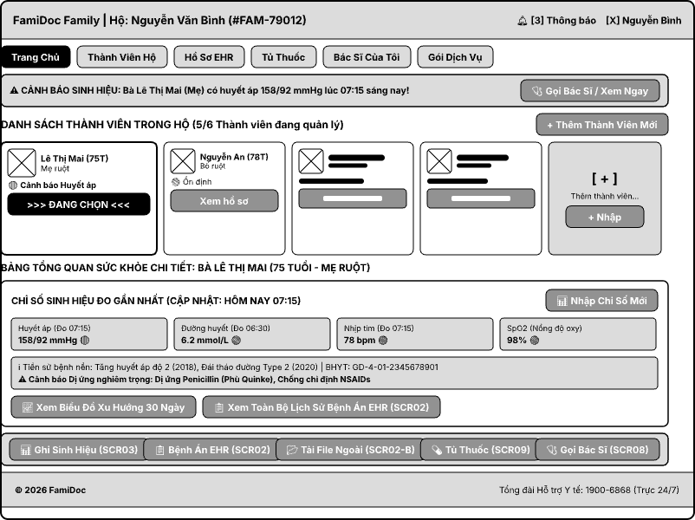
This screen allows the Family Representative to:
- Switch Monitored Member: Easily switch between multi-generational household members in the dynamic roster grid to view their dedicated health profile.
- Inspect Real-Time Vital Signs: Monitor the 4 core vital metrics (Blood Pressure, Blood Glucose, Heart Rate, SpO2) with measurement timestamps and color-coded threshold tags (normal vs. out-of-range).
- Review Chronic Conditions & Allergy Warnings: Inspect permanent chronic disease diagnoses and high-priority allergy contraindications linked to the patient's EHR.
- Access Core Health Modules: Navigate directly to vital sign logging, longitudinal EHR timeline, external diagnostic upload, medicine cabinet, and doctor consultation via persistent one-tap shortcuts.
Field Description
Field Name | Description
(1) Household & Profile Banner | Displays household representative name, Household ID (#FAM-79012), user avatar, notification badge (unread vital alerts count), and global navigation tabs (Home, Family Members, EHR Records, Medicine Cabinet, My Doctor, Service Packages).
(2) Vital Warning Strip (Alert Banner) | Prominent high-contrast alert strip displaying out-of-range vital measurements logged within the day (e.g., Mrs. Le Thi Mai - Blood Pressure 158/92 mmHg) with a quick-action button to contact the attending family doctor.
(3) Member Roster Cards | Flexible card collection displaying each family member with avatar, full name, age, family relationship, health status badge (
Add Dependent Member Button / Card | Action button [+ Add New Member] and card [ + ] opening a modal dialog to register a new household dependent (Full name, Date of Birth, Gender, Allergy history).
(4A) 4 Core Vital Signs Grid | 4 metric cards displayed in a single horizontal row showing latest values for: Blood Pressure (BP), Blood Glucose, Heart Rate (HR), and SpO2 with timestamps and clinical safety status.
(4B) Chronic Disease & Allergy Warning Bar | Fixed read-only clinical background container showing confirmed chronic conditions (ICD-10) and flashing red allergy warnings (e.g., Penicillin anaphylaxis, NSAID contraindication).
Vital Trend & EHR Shortcuts | Action buttons opening 30-day vital trend charts and direct navigation to the full longitudinal EHR timeline (SCR02).
(5) Quick Action Dock | 5 persistent high-contrast shortcut buttons providing one-tap navigation to: Log Vitals (SCR03), View EHR (SCR02), Upload External Docs (SCR02-B), Medicine Cabinet (SCR09), and Telehealth/Doctor Call (SCR08).
(6) Footer Landmark Bar | Standardized bottom landmark displaying enterprise platform copyright, ISO 9241-110 & Decree 13/2023/ND-CP compliance statement, and 24/7 medical support hotline (1900-6868).

1.2 View Longitudinal EHR Timeline & History
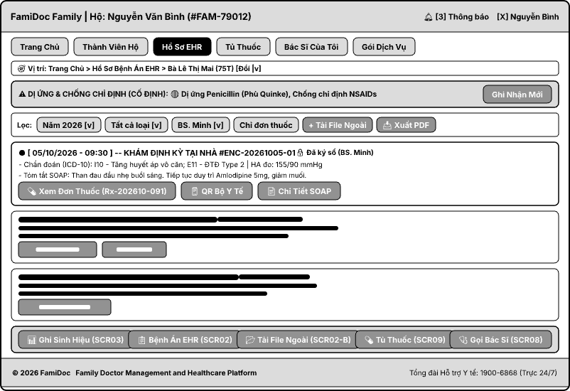
This screen allows the Family Representative and Attending Family Doctor to:
- Inspect Longitudinal EHR Timeline: Browse a continuous chronological stream of medical encounters (in-person home visits, video telehealth sessions, and external laboratory uploads) sorted from newest to oldest.
- Review Critical Allergies & Contraindications: Immediately identify life-threatening drug allergies (e.g., Penicillin anaphylaxis) and medical contraindications permanently pinned at the top of the clinical stream.
- Filter Clinical Encounters Multi-Dimensionally: Quickly isolate medical records by timeframe (year/month), encounter type (Home Visit, Telehealth, External Lab), attending physician, or prescription-only filters.
- Verify Clinical SOAP Notes & Diagnostic Codes: Examine structured clinical documentation (Subjective, Objective, Assessment, Plan) and international disease classification codes (ICD-10).
On the screen, s/he can also:
- Switch Monitored Family Member: Switch between household dependents directly from the contextual breadcrumb dropdown without navigating back to the home dashboard.
- Access Electronic Prescriptions & National QR Codes: Open linked e-prescriptions (Rx) and inspect standardized Ministry of Health QR codes for direct pharmacy dispensing.
- Upload External Diagnostic Documents: Trigger the external diagnostic upload modal (SCR02-B) directly from the filter toolbar.
- Export Medical Records & Verify Digital Signatures: Download certified clinical summary PDF reports and verify tamper-proof physician digital signatures ensuring EHR legal validity.
Field Description
Field Name | Description
(1) Household & Profile Banner | Displays household name, Household ID (#FAM-79012), user profile, and global navigation shell with the EHR Records tab highlighted in active state.
(2) Context Breadcrumb & Member Switcher | Breadcrumb navigation showing current location and an interactive dropdown selector to switch between family members (displaying name, age, and family relationship).
(3) Critical Allergy & Contraindication Strip | Permanently pinned high-priority alert bar (Red/High-contrast) highlighting active drug allergies and medical contraindications with an action button to record new clinical sensitivities.
(4) Multi-dimensional Filter Toolbar | Interactive toolbar providing quick multi-criteria filtering: Timeframe selector (Year 2026), Encounter type (All Types), Attending doctor (Dr. Minh), Prescription-only filter (Prescriptions Only), shortcut button to upload external docs (SCR02-B), and an Export PDF button.
(5) Chronological Encounter Stream | Vertical node stream arranging medical encounters chronologically from latest to oldest.
Encounter Header & Metadata | Displays encounter date/time, encounter type (Home Visit, Telehealth, Lab), Unique Encounter ID (#ENC-20261005-01), and attending physician credentials.
Diagnostic Coding (ICD-10) | Standard international disease codes (e.g., I10 - Essential Hypertension, E11 - Type 2 Diabetes) and clinical vitals recorded at point of care.
SOAP Clinical Summary | Concise structured note summarizing Subjective patient symptoms, Objective measurements, clinical Assessment, and care Plan.
Prescription & QR Shortcut | Interactive buttons to inspect the full electronic prescription (Rx-202610-091), national Ministry of Health QR code, and complete SOAP clinical details.

2. Doctor Onboarding, Verification & Matching Directory

2.1 Public Doctor Directory
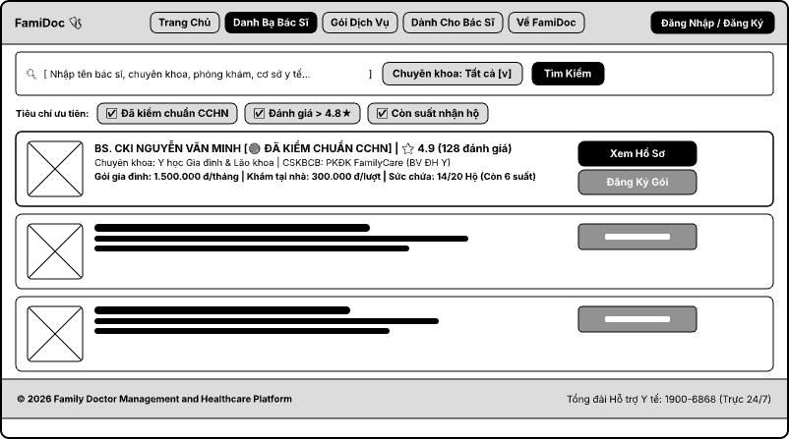
This screen allows Users / Family Representatives to:
- Search and Filter Specialized Doctors: Easily browse the doctor directory using keyword search (doctor name, specialty, clinic, healthcare facility) and filter by specialty.
- Screen by Quality and Availability: Quickly apply priority criteria including verified practicing license (CCHN), high ratings, and household intake capacity.
- Review Summary Profiles & Workload Capacity: Inspect professional qualifications, affiliated clinical facilities, service pricing (monthly family plan, per-visit home care), and remaining household capacity quota.
- Navigate to Detailed Profile & Subscribe: Access the physician's comprehensive credentials or initiate a family doctor subscription plan directly from the roster list.
Field Description
Field Name | Description
Logo & Primary Navigation Bar | Displays the FamiDoc brand logo alongside primary navigation tabs: Home, Doctor Directory (active state), Service Packages, For Doctors, and About FamiDoc.
Account Action Button | [Login / Register] button for user authentication and access management.
Keyword Search Input | Text input field allowing flexible queries by: Doctor name, medical specialty, clinic, or healthcare facility.
Specialty Dropdown Selector | Dropdown menu to filter physicians by medical department (Default: Specialty: All).
Search Trigger Button | Action button [Search] to execute the query based on current input parameters.
Quick-filter Checkboxes | Three pre-configured filtering checkboxes:  • Verified Practice License: Filters for physicians with verified credentials (CCHN).  • Rating : Shows highly rated practitioners.  • Available Household Quota: Limits results to doctors currently accepting new families.
Doctor Card Container | Comprehensive card module presenting detailed professional and operational metrics:  • Avatar: Professional profile photo of the doctor.  • Full Name & Verification: Academic title, physician name, and verified practicing license badge [VERIFIED PRACTICE LICENSE].  • Rating & Reviews: Star rating average and total review count • Specialty & Facility: Medical specialty and affiliated healthcare facility  • Fee Schedule: Pricing for the recurring family plan and per-session home visit fee.  • Workload Capacity: Household capacity status and remaining intake quota (e.g., 14/20 Households
Card Action Buttons | • [View Profile]: Navigates to the comprehensive profile page detailing clinical experience, background, and schedule.  • [Subscribe Plan]: Launches the enrollment workflow for the family healthcare contract with the chosen practitioner.
Platform Copyright & Support Landmark | Displays enterprise platform Family Doctor Management and Healthcare Platform and 24/7 medical support hotline (1900-6868).

2.2 Public Doctor Profile & Practice Schedule
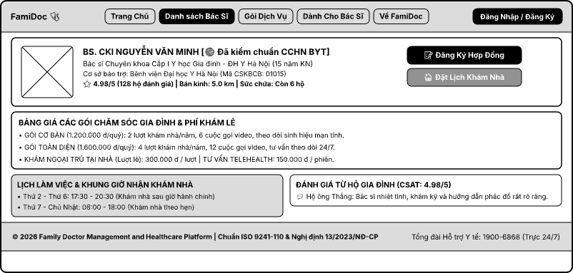
This screen allows Users / Family Representatives to:
- Inspect Detailed Doctor Credentials: View the doctor's portrait, academic title/degree, specialty, years of experience, supporting healthcare facility, and the Ministry of Health verification status of the practicing license.
- View Ratings & Service Radius: Check actual rating scores from households, the in-home service radius, and the number of remaining household intake slots.
- Survey Service Pricing: View detailed benefits and costs of quarterly family care packages (Basic Package, Comprehensive Package) along with per-service fees (in-home outpatient visit, Telehealth consultation).
- Track Working Schedule & Book Appointments: Grasp the available home-visit time slots on weekdays/weekends and read real feedback from households that have already used the service.
- Perform Registration Actions: Quickly sign a long-term family doctor contract or book a home visit appointment via the prominent action buttons.
Field Description
Field Name | Description
Household & Navigation Shell | Displays the FamiDoc brand, the main navigation tabs (Home, Doctor Directory [currently selected], Service Packages, For Doctors, About FamiDoc), and the [Login / Register] button.
Doctor Profile Header & Photo | Displays the portrait photo, the doctor's full name (Dr. CKI NGUYEN VAN MINH), and the electronic verification badge [MoH Practice License Verified (CCHN)].
Specialty & Qualifications | Shows the degree, trained specialty, and clinical experience: Level I Specialist in Family Medicine - Hanoi Medical University (15 years of experience).
Affiliated Healthcare Facility | The healthcare facility for practice and professional support: Hanoi Medical University Hospital (Healthcare Facility Code: 01015).
Operating Metrics & Ratings | Displays the service quality score 4.98/5 (128 household reviews) and the capacity indicator: 6 households remaining.
Contract Registration Action | Quick-action button [Subscribe Contract] that opens the registration workflow for a recurring family health care package.
Home Visit Booking Action | Quick-action button [Book Home Visit] that opens the appointment form for the doctor to visit and examine the patient on site.
Family Care Packages Pricing | Pricing table for the recurring service packages:  • Basic Package (1,200,000 VND/quarter): 2 home visits/year, 6 video calls, chronic vital sign monitoring.  • Comprehensive Package (1,600,000 VND/quarter): 4 home visits/year, 12 video calls, 24/7 monitoring consultation.
On-demand Service Fees | Pricing of on-demand per-visit services:  • In-home outpatient visit: 300,000 VND / visit.  • Remote Telehealth consultation: 150,000 VND / session.
Home Visit Working Schedule | Time slots available for booking home visits:  • Mon – Fri: 17:30 - 20:30 (home visits after office hours).  • Sat – Sun: 08:00 - 18:00 (home visits by appointment).
Household Customer Reviews (CSAT) | Area displaying the customer satisfaction score (CSAT: 4.98/5) and real feedback from households (e.g., Mr. Thang's household: The doctor was very enthusiastic, examined our elderly family member carefully, and explained the treatment protocol very clearly.).
Footer Landmark Bar | Footer bar displaying the Family Doctor Management and Healthcare Platform, the ISO 9241-110 & Decree 13/2023/ND-CP compliance statement, and the Medical Support Hotline: 1900-6868 (available 24/7).

2.3 Doctor Registration & Credentials Submission

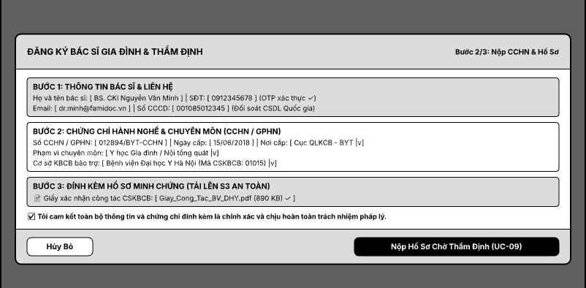
This screen allows the Doctor to complete the practice registration and professional credential verification workflow into the family healthcare network:
- Verify Identification & Contact Information: Review and complete personal identity and contact details along with their secure verification status.
- Declare Medical Professional Competence: Provide the Medical Practice Certificate / Practice License (CCHN / GPHN) number, issue date, issuing authority, scope of professional practice, and the sponsoring healthcare examination and treatment facility (CSKBCB).
- Attach Evidence Documents Securely: Upload valid proof-of-practice document files to the secure cloud storage system (S3).
- Commit to Responsibility & Submit for Verification: Acknowledge the legal validity of the application and submit the request to the credential verification workflow (UC-09).
Field Description
Field Name | Description
Page Title & Step Indicator | Displays the workflow title FAMILY DOCTOR REGISTRATION & VERIFICATION together with the step progress: Step 2/3: Submit CCHN & Documents.
Doctor Information & Contact (Step 1) | Personal and contact information block of the doctor:  • Doctor's full name: Dr. CKI Nguyen Van Minh.  • Phone number: 0912345678 with the confirmation label {OTP verified }.  • Email: dr.minh@famidoc.vn.  • Personal identity: Displays the status {National Database Cross-check}.
Practice Credentials & Specialty (Step 2) | Professional practice declaration block:  • CCHN / GPHN number: 012894/BYT-CCHN.  • Issue date & issuing authority: Issue date 15/06/2018, Issuing authority: Department of Medical Examination and Treatment Management - MoH (dropdown menu).  • Professional scope: Specialty category selector field (Family Medicine / General Internal Medicine).  • Sponsoring healthcare facility: Facility selector field (Hanoi Medical University Hospital (Healthcare Facility Code: 01015)).
Document Attachment & Upload (Step 3) | Secure cloud storage document upload area:  • Attachment: Facility practice confirmation letter (Giay_Cong_Tac_BV_DHY.pdf).
Legal Compliance Checkbox | Mandatory checkbox confirming accuracy and legal accountability: certify that all information and attached certificates are accurate and I accept full legal responsibility.
Cancel Action | [Cancel] button allowing the current registration action to be cancelled and returning to the previous step or exiting the workflow.
Submit for Verification Action | Primary action button [Submit Application Pending Verification (UC-09)] to send all data to the system and change the application status to pending professional verification.

2.4 Smart Doctor Matching Wizard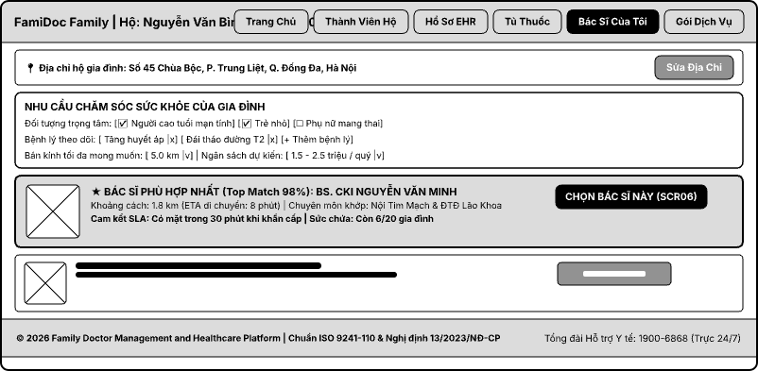
This screen allows the User / Family Representative to perform intelligent matching with the most suitable family doctor:
- Confirm Household Address: Review and edit the family's registered home address to ensure accurate home-visit planning.
- Declare Household Medical Needs: Set in-depth criteria including the priority target group requiring focused care, the chronic conditions under monitoring, the maximum desired radius, and the estimated budget per quarter.
- Receive Algorithm-based Doctor Recommendations: View the list of suggested doctors ranked by decreasing suitability (Top Match %) together with real parameters such as distance, estimated travel time, corresponding specialty, and emergency SLA commitment.
- Select Doctor & Proceed to Signing: Choose the optimal doctor to be forwarded immediately to the contract completion or care agreement workflow (SCR06).
Field Description
Field Name | Description
Household & Navigation Shell | Displays the household identity (FamiDoc Family | Household: Nguyen Van Binh), together with the main navigation tabs: Home, Household Members, EHR Records, Medicine Cabinet, My Doctor (active state), Service Packages.
Household Address Bar | Displays the household's actual address (No. 45 Chua Boc, Trung Liet Ward, Dong Da District, Hanoi) together with the action button [Edit Address] to update the home coordinates/location.
Family Healthcare Needs Settings | Block for configuring the household's doctor search and matching criteria:  • Priority target group: Checkboxes selecting the priority group.  • Conditions under monitoring: Condition tags to be managed.  • Estimated budget: Dropdown selecting the care cost range.
Top Matched Doctor Card | Card displaying the doctor with the highest compatibility score according to the algorithm:  • Portrait photo: Doctor's avatar image frame.  • Title & Compatibility: BEST MATCHED DOCTOR (Top Match 98%): Dr. CKI NGUYEN VAN MINH.  • Matched specialty: Cardiovascular Internal Medicine & Geriatric Diabetes.  • SLA commitment & capacity: SLA commitment for emergencies | Capacity: 6/20 households remaining.
Doctor Selection Action | Prominent button [SELECT THIS DOCTOR (SCR06)] to move the user to the next contract setup and service registration step.
Alternative Matched Doctor Cards | Cards displaying the list of subsequent suitable doctors with lower match percentages for the user to consider as backups.
Footer Landmark Bar | Standardized footer bar showing the system Family Doctor Management and Healthcare Platform, the ISO 9241-110 & Decree 13/2023/ND-CP compliance statement, and the Medical Support Hotline: 1900-6868 (available 24/7).

3. Chronic Care Continuous Monitoring & Vital Alerting

3.1 Record Vital Signs & Abnormal Threshold Alert
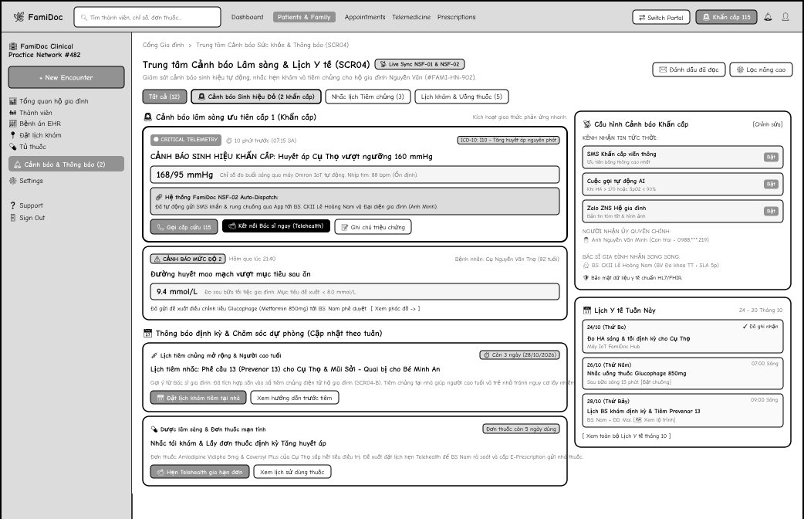
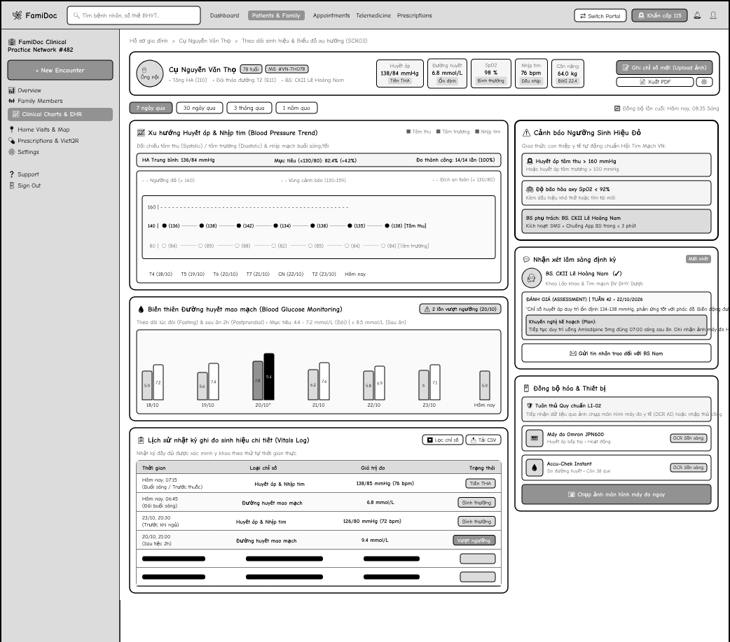

4. Hybrid Care (Video Calls & Home Visits)

4.1 Book Consultation Appointment (Home / Video) & Record SOAP Clinical Encounter
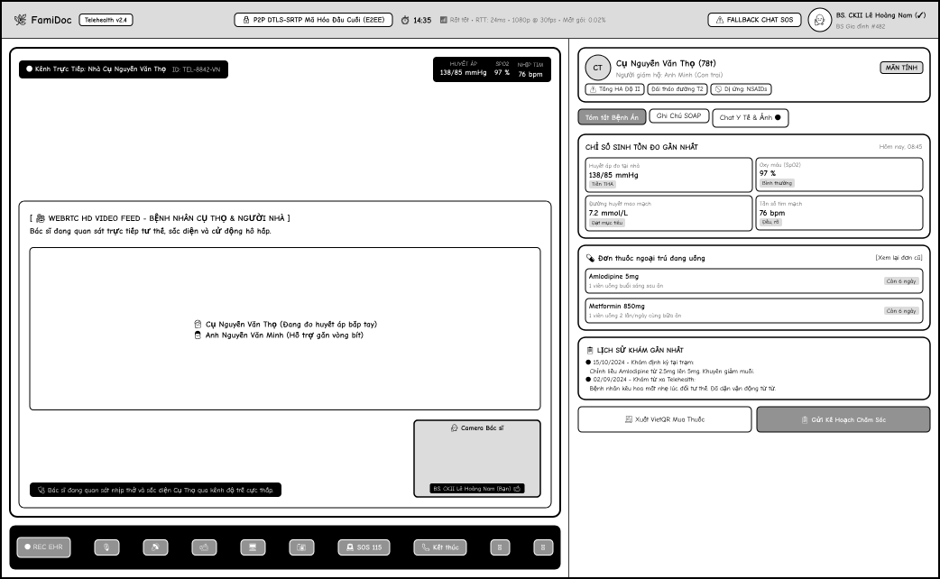

5. Healthcare Subscription & Service Contract Management

5.1 Subscribe to Care Package & Sign Electronic Contract
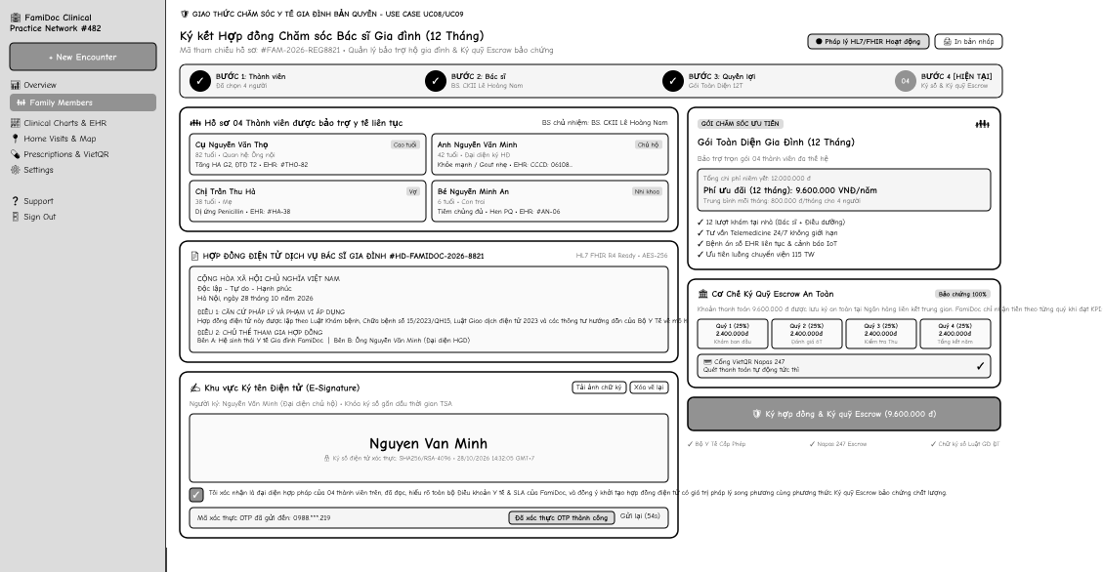
This screen allows the Family Representative to:
Select Care Package: select a suitable healthcare service package (e.g., Monthly, Quarterly, Annual) based on family needs.
Select Covered Members: choose the family members to be covered under the selected care package.
Review Contract Terms: read the electronic contract details, including SLA commitments, payment terms, and cancellation policies.
Sign Electronic Contract: confirm and digitally sign the care contract to establish the healthcare partnership.
Proceed to Payment: view the dynamic VietQR code to make the subscription payment and activate the contract.
Field Description
Field Name | Description
Breadcrumb | Shows the navigation path, e.g. Doctor Profile > Sign Care Contract. Allows the user to return to the previous level
Doctor Summary | Read-only. Displays the selected doctor's avatar, full name, specialty, and rating
Package Selection | Dropdown. Selects the available service package and billing cycle (Monthly, Quarterly, Annual)
Package Benefits | Read-only. Displays the specific benefits of the package, such as home visit and telehealth quotas
Covered Members | Checkbox list. Selects which dependent family members will be included in the care contract
Contract Content | Read-only. Scrollable area displaying the full legal terms, SLAs, and platform liability policies
Terms & Conditions Checkbox | Required checkbox to acknowledge and agree to the contract terms and conditions
Confirm Signature button | Digitally signs the contract, submits the subscription request, and proceeds to the payment step
Cancel button | Cancels the subscription process and returns the user to the doctor's profile

IV. Non-Functional Requirements

1. External Interfaces

1.1 User Interfaces
Responsive Web & PWA Application Platform
- The system is built as a modern Responsive Web application using Next.js 14 and React, integrated with Progressive Web App (PWA) technology. This allows users to add a shortcut icon to their mobile home screen without developing native iOS/Android apps
- The interface automatically adapts across three display categories:
- Desktop / Laptop (Width >= 1200px) — for Doctors managing case files and Backoffice Administrators.
- Tablet (768px – 1199px) — for Doctors during home visits.
- Mobile Web / PWA (375px – 767px) — for Household Representatives tracking health status and communicating.
Accessibility & Ergonomics Standards:
- Minimum touch target size is 44x44 CSS pixels on mobile devices to prevent accidental touches for elderly users or those experiencing symptoms.
- High-contrast color palette compliant with international WCAG 2.1 Level AA standards (minimum contrast ratio of 4.5:1 for regular text, 3:1 for headers and key UI elements).
- Includes a Senior Accessibility Mode: enables larger base font size (base font size >= 18px), enhanced contrast, and clear visual iconography.

1.2 Hardware Interfaces
- Strict Compliance with Exclusion Constraint LI-02 (No direct IoT hardware integration):
- The system strictly avoids direct connections to medical devices via Bluetooth (BLE), cables, or Hardware SDKs.
- All vital sign metrics (Blood Pressure, Heart Rate, Blood Glucose, SpO2, Weight) are recorded through:
    - Manual data entry directly into Web/PWA forms .
    - Uploading screenshots of measurement monitors or external lab test result slips.
- Audio & Video Hardware (Telehealth Audio / Video):
- Interacts with personal device cameras, microphone arrays, and speakers (laptops, smartphones, tablets) via the standard browser API navigator.mediaDevices.getUserMedia (WebRTC).
- Supports HD 720p/1080p video transmission at 24–30 fps, with built-in browser noise suppression and Acoustic Echo Cancellation (AEC) for online Telehealth consultations.

1.3 Software Interfaces
- PostgreSQL 15+ Database Management System: Stores all relational data ensuring atomic transaction integrity (ACID) for intergenerational EHR records, family care contracts. All tables support a soft deletion mechanism (deleted_at).
- Redis 7.2 Cache: Manages high-speed user sessions, distributed locking to prevent appointment schedule conflicts, and temporary caching for consultation chat messages.
- MinIO S3 Object Storage: Securely stores attached medical document files (external lab test results UC05, pathological lesion images, doctor practicing certificates, and recorded Telehealth consultation videos).
- International Medical Classifications (ICD-10 & National Formulary): Integrates international disease coding standards (ICD-10 per WHO and Ministry of Health regulations) for SOAP medical records (UC23) and official active pharmaceutical ingredients for e-prescriptions (UC24).

1.4 Communications Interfaces
- Secure Application Protocols: All communications between Web/PWA browsers and Backend API servers must be encrypted via HTTPS over TLS 1.3 (with backward compatibility to TLS 1.2 minimum; TLS 1.0 and 1.1 strictly disabled).
- Online Audio/Video Streaming Protocols (WebRTC): Uses DTLS-SRTP encryption protocol, ensuring audio/video data in Telehealth sessions is end-to-end encrypted to prevent eavesdropping.
- Secure WebSocket Channel: Handles instant medical messaging and pathological lesion image sharing between Doctors and Household Representatives, supports emergency escalation triggers, and delivers real-time abnormal vital sign alerts.

2. Quality Attributes

2.1 Usability
The usability of the FamiDoc platform is evaluated and ensured through four key quantitative metrics along with their corresponding verification methods:
- Household Head Onboarding Time: The system targets allowing a new Household Representative to independently complete account registration , family profile setup, and the addition of two dependent members within a maximum of 5 minutes without any technical assistance. This metric is verified through real-world user experience testing conducted on a cohort of 10 first-time users.
- Doctor Operational Efficiency: To streamline clinical workflows, doctors are required to complete SOAP clinical medical notes and digitally sign and issue e-prescriptions within a maximum of 3 minutes during or immediately after a consultation session. This target is evaluated using stopwatch time-and-motion testing on 20 simulated clinical cases.
- Appointment Booking Success Rate: The proportion of patients successfully completing a home visit booking or accessing a Telehealth consultation room on their first attempt must reach at least 92%. This metric is measured by tracking completion rates across the user action log analytics funnel.
- User-Friendly Error Interface: All (100%) error messages displayed to users must be written in plain, natural language, clearly state the root cause, and include a single-tap action button for resolution or retry. This requirement is validated through automated reviews across all front-end interface test scripts.

2.2 Performance
Requirement | Target | Condition
Initial Web Page Load Time | All pages on the Web/PWA app load and become Time to Interactive (TTI) within <= 2.0 seconds. | 4G/Broadband network. Measured using Google Lighthouse.
Telehealth Connection & Latency | Video stream initiates quickly; audio/video two-way round-trip latency remains <= 150 ms with adaptive quality. | Both users are on a stable internet connection (>= 2 Mbps). Measured using WebRTC Internals.
Backend API Response Time | Core NestJS backend APIs (scheduling, medical record retrieval) respond within <= 500 ms (P95). | Single VPS deployment. Load tested using Apache JMeter.
Form Submission Speed | System stores and responds to form submissions (vitals, prescriptions, appointments) within <= 1.5 seconds. | Load environment with up to 100 concurrent requests.
Maximum Simultaneous Users | System remains fully functional and maintains stable performance for up to 1,000 concurrent users (CCU). | Single VPS deployment (NestJS Backend + PostgreSQL). Stress tested using Apache JMeter.
Database Query Speed | 99% of read queries complete in <= 50 ms; write transactions complete in <= 100 ms. | Dataset scale of 100,000 medical history records. Measured using PostgreSQL EXPLAIN ANALYZE.

2.3 Security
Requirement | Description
Authentication & RBAC | Strict Role-Based Access Control (RBAC) is enforced. Every API endpoint and page, apart from the public landing and registration pages, requires authentication with a valid JWT token. Doctors, Admins, and Family Representatives are restricted to their specific modules.
Password & Token Protection | Passwords must be cryptographically hashed using Argon2id (64MB memory, 3 iterations, parallelism degree 1) with unique cryptographic salts and never stored in plain text. Accounts are temporarily locked for 30 minutes after 5 consecutive failed attempts to prevent brute-force attacks
Data Encryption (EHR) | Longitudinal electronic health records (EHR) and sensitive patient data are protected. Sensitive medical files stored in MinIO are encrypted at rest using AES-256-GCM, and network transmission is encrypted via HTTPS TLS 1.3.
Telehealth & Messaging Privacy | Remote video consultations are encrypted using WebRTC (DTLS-SRTP). Direct medical chats and real-time alerts are transmitted securely via WebSocket over TLS 1.3 (WSS), ensuring data is encrypted in transit but not strictly end-to-end encrypted (E2EE) to allow Admin dispute moderation.
E-Prescription & AI Scope Compliance | E-prescriptions require doctor digital signatures and are immutable once issued. Automated AI disease diagnosis is forbidden; diagnostic decisions remain exclusively with human licensed doctors (LI-06)
Data Privacy & Compliance (NĐ 13/2023/NĐ-CP) | In strict compliance with Vietnam's Decree 13/2023/NĐ-CP regarding sensitive personal data (health data), the system enforces explicit user consent (opt-in checkbox) during registration. Encryption keys are managed securely via a Key Management Service (KMS) or strict environment variables. Medical records and data retention periods comply with Ministry of Health regulations (e.g., retained for 10 years for outpatient records), after which data is securely purged.
Audit Logging & Consent Authorization | All EHR read accesses (READ_EHR), prescription issuances, and financial operations are permanently recorded in immutable audit logs (audit_logs where UPDATE/DELETE are revoked). Access to EHR requires explicit legal authorization consent

V. Requirement Appendix

1. Business Rules
GB-ID | Rule Statement | Applies To | Rationale | Enforced By
GB-01 | Each entity follows its defined transition rules. Invalid transitions are rejected and accepted changes are audited. Finalized clinical records cannot be overwritten; corrections are recorded as addenda. Payment history is preserved even when a request fails or expires. | Contract status, Appointment status, Encounter status, Payment status, Payout status, Dispute status, Doctor verification status | Prevents data integrity loss; maintains clear audit trail. | The system automatically on every status change
GB-02 | A family member's medical records (EHR, vital signs, documents, prescriptions, chat and photos) are visible only to the family representative and to doctors with an active care contract or an active encounter with that member. | EHR Timeline, uploaded documents, Clinical Encounters, prescriptions, medical chat | Protects sensitive health data and patient privacy. | The system automatically on every page and data request
GB-03 | Medical files (lab results, uploaded documents, medical photos) may only be accessed by users authorized to view the associated member's record. Access is verified on every download. | All medical file access | Prevents unauthorized access to personal health information. | The system automatically on every file access request
GB-04 | Clinical Encounter records are immutable once completed. Doctors may only add signed addenda, never edit or delete the original content. | Clinical Encounter, e-Prescription | Ensures medical-legal integrity and traceability. | The system automatically when an encounter is completed
GB-05 | When sign-in fails, the message must not reveal whether the account exists or the password was wrong. | Sign-in (all roles) | Prevents attackers from discovering valid accounts. | The system automatically on every failed sign-in
GB-06 | Deactivated or suspended accounts cannot access protected functions. Doctors with verified accounts but unapproved credentials may access only onboarding and profile setup permitted for their review status. Only approved doctors may accept care contracts or provide consultations. | Sign-in, all role-based actions | Ensures removed or unqualified users lose access immediately. | The system automatically on every sign-in attempt
GB-07 | A doctor may only accept contracts, home visits, and telehealth sessions after their credentials have been verified and approved by an Admin. | Doctor contract acceptance, visit and telehealth handling | Ensures only qualified, licensed practitioners provide care. | The system automatically on every doctor action
GB-08 | MAX_PANEL_CAPACITY enforces the maximum number of Active family contracts assigned to one doctor (default 30). The system atomically validates and increments active counts upon contract activation. | Contract acceptance, doctor search results | Maintains service quality and prevents doctor overload. | The system automatically on every contract acceptance
GB-09 | Home visits require an authorized covered member, an Active contract, a manually entered address and doctor acceptance. No geographic eligibility calculation is performed. | Home Visit booking, doctor matching | Ensures continuity of care and feasible service delivery. | The system automatically on every booking or matching request
GB-10 | E-prescriptions must pass the drug-allergy and interaction check before they can be issued. A flagged conflict requires the doctor to revise the prescription or record an explicit override reason. | e-Prescription | Protects patient safety. | The system automatically on every prescription submission
GB-11 | Care package fees are charged in advance per billing cycle. A failed payment makes the contract overdue, and services are suspended after the grace period defined in system configuration. | Recurring payment, contract status | Ensures predictable revenue and fair service delivery. | The system automatically on every billing cycle
GB-12 | Contract termination records the reason, effective time and applicable service-access changes. This release does not calculate or process monetary refunds or financial settlement. | Contract termination and settlement | Ensures fairness to both families and doctors. | The system automatically on every termination request
GB-13 | Only families with a completed encounter or visit with a doctor may rate that doctor, once per encounter. Submitted ratings cannot be edited or deleted by the family. | Doctor rating | Prevents fake and duplicate reviews. | The system automatically on every rating submission
GB-14 | Doctor payouts are calculated only from completed and paid services, after deducting the platform commission. Payouts cannot exceed the doctor's available balance. | Revenue statement, withdrawal, payout orders | Ensures accurate and auditable financial settlement. | The system automatically on every withdrawal or reconciliation
GB-15 | An emergency Telehealth-to-Chat conversion must preserve the session record, and the conversation is attached to the same encounter. | Telehealth call, medical chat | Maintains continuity and completeness of the medical record. | The system automatically on every conversion
GB-16 | Every sensitive action (record view, edit, export, contract change, payout, credential review, configuration change) must be logged with user, time, and action. Logs cannot be modified or deleted. | All sensitive actions | Supports auditing, compliance, and dispute resolution. | The system automatically on every sensitive action
GB-17 | Dependent member profiles (minors, elderly) are managed only by the family representative who created them. Representatives must confirm authority to manage each dependent. | Dependent profile, member data | Ensures lawful consent and protects vulnerable members. | The system automatically on every profile creation and update
GB-18 | System configuration changes (fees, commission, panel cap, grace period) apply only to future transactions and contracts, never retroactively. | System configuration | Prevents disputes over changed terms. | The system automatically on every configuration change
GB-19 | A family household may maintain at most one Active family doctor retainer contract at any given time. | Family Contract Registration | Ensures the exclusive concierge care model and prevents conflicting medical care plans. | The system automatically verifies and blocks new contract creation if an Active one exists.
GB-20 | The platform acts solely as a technological intermediary connecting patients with independent licensed doctors. The platform explicitly disclaims liability for medical malpractice, misdiagnosis, or adverse treatment outcomes, which remain the sole professional and legal responsibility of the attending physician. | User Registration, Checkout, Clinical Encounters | Legal compliance and liability protection for the software platform provider. | Mandatory Terms & Conditions (T&C) acceptance checkbox during account registration and prior to signing the care contract.

2. System Messages
# | Message code | Message Type | Context | Content
1 | MSG01 | In line | There is no search result | No search results.
2 | MSG02 | In red, under the text box | Required input fields are empty | The * field is required.
3 | MSG03 | Toast message | Updating information successfully | Update {item} successfully.
4 | MSG04 | Toast message | Adding new record successfully | Add {item} successfully.
5 | MSG05 | Toast message | Confirmation email is sent successfully | A confirmation email has been sent to {email_address}.
6 | MSG06 | In red, under the text box | Input value length > max length | Exceed max length of {max_length}.
7 | MSG07 | In line | Username or password is not correct when signing in | Incorrect username or password. Please check again.
8 | MSG08 | In line | Account is deactivated, suspended, or not verified | Your account cannot be used to sign in. Please contact support.
9 | MSG09 | In red, under the text box | Email or phone number already exists when registering | This {email/phone} is already registered.
10 | MSG10 | Toast message | Session expired | Your session has expired. Please sign in again.
11 | MSG11 | In line | EHR Timeline has no records | No medical records available.
12 | MSG12 | In red, under the text box | Uploaded file format or size is not allowed | File must be {allowed_formats} and not exceed {max_size} MB.
13 | MSG13 | In line | No doctor matches the search criteria | No suitable doctor found. Please adjust your search criteria.
14 | MSG14 | In line | Doctor has reached the Panel Cap | This doctor is not accepting new patients at the moment.
15 | MSG15 | Toast message | Payment completed successfully | Payment successful. Your care package is active.
16 | MSG16 | In line | Payment failed | Payment failed. Please check your payment method and try again.
17 | MSG17 | Pop-up | Confirm contract termination | Are you sure you want to terminate this contract? This action cannot be undone.
18 | MSG18 | Toast message | Home visit booked successfully | Home visit booked for {date_time}.
19 | MSG19 | In line | Outside Service Area [Removed] | [Removed - Geolocation and radius checks are excluded from v1]
20 | MSG20 | In line | Selected time slot is no longer available | This time slot is no longer available. Please choose another.
21 | MSG21 | Toast message | Telehealth call converted to emergency chat | Video is unavailable. The consultation has switched to audio or chat.
22 | MSG22 | Pop-up | Drug-allergy or interaction conflict detected | Warning: {drug_name} conflicts with {allergy/drug}. Please revise or provide an override reason.
23 | MSG23 | Toast message | Encounter completed successfully | Encounter completed. Medical record and timeline updated.
25 | MSG24 | In line | User has no permission to access the resource | You do not have permission to access this content.
26 | MSG25 | Toast message | System error or server is unavailable | Something went wrong. Please try again later.

3. Other Requirements

